GCE Computer Science (7517)
The Practical Project

Centre number |  | Centre name
22133 |  | The Perse School

Candidate’s full name |  | Candidate number
Daniel Vlasits |  | 8383

Project title
Unit Testing/Analysing Tool
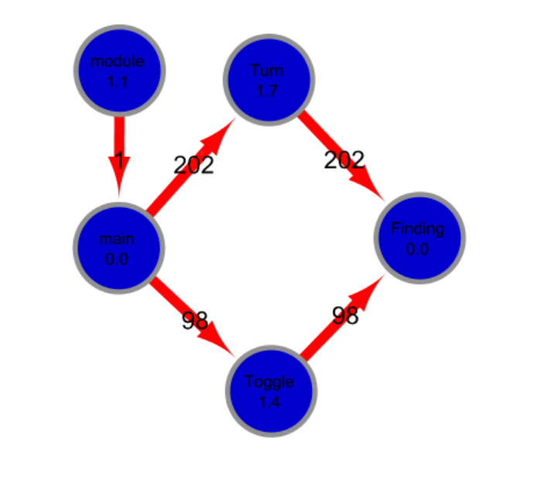
Contents
1 Analysis 3
1.1 Background to/ Identification of the problem 3
1.2 Research carried out 3
1.3 Identification of the prospective user(s) 4
1.4 Numbered, measurable, appropriate specific objectives of the project 4
1.5 Modelling diagrams 5
2 Design 6
2.1 System design overview 6
2.2 Algorithms 11
2.3 Data structures 17
2.4 File structure and organisation 18
2.5 Database design 19
2.6 User interface design (HCI) 19
3 Technical Solution 21
3.1 Completeness Section 21
3.2 Objectives Revisited 21
3.3 Technical Skills Section 21
3.4 Code listing 22
4 System testing 46
4.1 Test plan 46
4.2 Annotated screenshots of test results 49
5 Evaluation 60
5.1 Comparison of project performance against the objectives 60
5.2 Effectiveness of the solution 60
5.3 Analysis of user feedback 60
5.4 Possible improvements 60
6 Appendix 60

Analysis

Background to/ Identification of the problem

My project is to create an automated software analysis tool (profiler) that will be used as a unit tester for developers who are writing code in Python and need help analysing it. This comes in two forms, static and dynamic analysis. The profiler tool should statically analyse the target code provided by the developer to help them meet their companies’ code standards. The tool should also be capable of running testcases and detecting when outputs do not match ones required. This allows regular checking of the target program that when edits are made it still meets the specification. The profiler should also give the user a better overview of their code. This will allow them to easily see what parts of the code need optimization and where the bottleneck in the code is.

Research carried out

I first looked through many Wikipedia pages looking at the different types of methods for analysing code. This introduced me to the two types of code analysis: static and dynamic. Static code analysis involves examining the target code without running it and looking to generate basic metrics such as number of lines and functions. Dynamic analysis is where the code to be analysed is run with test cases. This can be done using Black-box methods where inputs are tested and outputs are compared to the expected output. However, while the code is running you can take metrics as well and look at how the code and different functions are preforming.

Matlab has a built in profiler which gathers metrics on the timings and frequencies of the functions called and used. These metrics can then be examined by the user and the best functions for improvement for maximum benefit can be implemented. Matlab also suggests users make edits then rerun the profiling code and see how the metrics compare. Another metric to be analysed is called Cyclometric Complexity which looks at the number of paths through the code and is useful for the developer as if this is too high the code is too complex.

I learnt about how unit testing involves testing the individual units of source code together with inputs to determine whether they are fit for use. This could be one module of procedural code that is run with inputs to determine whether it functions as expected. This can then be combined with the dynamic and static analysis talked about earlier to allow the developer to optimise their module.

Interview Questions:

I interviewed the head of software at a Cambridge based company.

- What basic information needs to be statically analysed
“Basic information is very useful such as number of lines, comments and functions. Then analysis on the functions further is useful such as length and number of parameters and variables used which allows for very good management of the code”
- What key features does the GUI need?
“The GUI just needs to allow for data to be taken in”
- How should the tool take in the script?
“The GUI should allow for you to browse your file and locate the script”
- How should the profiler output data
“An excel file is very useful as an output as anyone can read it and the data can be easily edited, manipulated and sent to colleagues”
- How should the profiler take in the testcases?
“You could also use the excel table to take in these kinds of information just by writing the testcases in the file and having the code take it in”
- Do you have any thoughts for types of dynamic analysis to run on the target code that would be useful?
“You could look at paths through the code, also potentially look at only displaying parts of the graph that branch and ignore any other. This is so that for large call graphs it is much easier to view the branches and options through the code which is the most important part. Then as a user it would be much clearer to me what parts of the code use the most time. Along the same idea, looking at the number of paths through the code is also very useful then we know number of testcases we need and in general how complicated it is.”

Identification of the prospective user(s)
The tool is intended for any software developer who writes python code and needs help in analysing it for metrics and for parts to optimise.

Numbered, measurable, appropriate specific objectives of the project

Each objective has more detail in the Design section.

Stage 1
- The profiler takes in a python script using a GUI
- The profiler takes in a Excel Spreadsheet using a GUI
- The profiler takes in a save location using a GUI
- The profiler calculates the total number of lines in the script
- The profiler calculates the total number of comments in the script
- The profiler calculates the number of functions
- The profiler finds the number of parameters for each function
- The profiler finds the number of local variables for each function
- The profiler finds the names of all local variable in each function
- The profiler can edit the Excel spreadsheet with the results
- The profiler can save the Excel spreadsheet to the save destination
Stage 2
- The profiler can take in inputs to be run on the target code
- The profiler can alter the target code to allow inputs to be run instead of being requested
- The profiler can run the target code so that it runs with the desired inputs
- The profiler alters the target code so that outputs are saved instead of output
- The profiler saves these outputs to the Excel file
- The profiler can take in desired outputs wanted from a certain batch of inputs
- The profiler can highlight outputs that do not match outputs wanted
- The profiler can take in user preferences such as maximum number of line and maximum number of comments
The profiler can store user preferences in a sql table
- The profiler can highlight when the target code does not hit preferences required for example if there are more lines than what is specified by the user
Stage 3
- Call graph can be generated from the static analysed data
- Call graph can be viewed by user
- The profiler stores all previous Excel spreadsheet locations of a user and the time they were generated
- The profiler can run code and gather times each function is run for
- The profiler can calculate the time each function is run for without being in another function within that function
- The profiler can find the number of times each function calls another function
- The profiler can create a call graph displaying information collected
- The profiler can find any lines in graph without branches and condense them
- Calculate the number of paths through the dynamically created call graph

Modelling diagrams

Here is what the flow diagram of the code should look like:

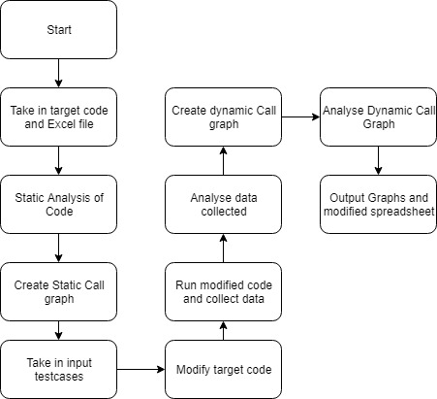

Design

System design overview
The system will work as a unit tester for developers allowing them to input a file of procedural python code on which it will then preform static and dynamic analysis outputting the data it collects.

Static analysis consists of looking at the code without running it and gathering metrics such as number of lines and number of comments. Dynamic analysis is where you analyse the code by running it with inputs and seeing how it preforms. For my dynamic analysis I will initially look at whether for each corresponding input the expected output is produced. The other key thing to look at will be the timings spent in each function and the graph generated.

A call graph will also be generated showing how each function calls other functions and the times spent inside each function. This allows the user to have an overview of the bottlenecks in the code and how many times functions call each other. Three further functions will be preformed on the graph:

- Condense any straight lines without branching in the graph.
- Check whether there are any cycles in the graph indicating recursion
- Calculate the number of paths from the start node through the graph

Static analysis

- Number of lines:
  - This will be achieved by using the inbuilt splitlines function in python combined with the len command.

- Number of comments
  - This will be done by looking for lines with the # symbol in. The profiler code will then proceed to loop through the line character by character keeping track of whether there are any open quotes. Furthermore, as there are two quotation symbols if one of them are currently open then the other quotation will be ignored. When the hashtag symbol is reached if the quotes are open then it will not be counted but, if at any point in the line there is a # not after a set of quotes that make it open then it will be counted. Here is some example pseudocode:

#Start with no comments
NumComments = 0
#Loop through all the lines in the code
for line in script.splitlines():
if "#" in line:
#If line contains a # procced to check
#if the # is not inside a quote
OpenSingle = 0
OpenDouble = 0
Correct = 0
#Loop through all charachters in line
for char in line:
#if you have single quotes and not within a double quotes
#then toggle the single quote open variable
if char == "'" and OpenDouble == 0:
OpenSingle += 1
OpenSingle %= 2
#if you have double quotes and not within single quotes
#then toggle the double quote open variable
if char == '"' and OpenSingle == 0:
OpenDouble += 1
OpenDouble %= 2
#If come across a hasthag check both open variable
#set to 0 and if so it is a comment
if char == "#" and OpenDouble == 0 and OpenSingle == 0:
Correct = 1
#Whole line looped through as there could be a valid #
#even if one of them wasn't valid
#increment number of comments by one if Correct was set to one
if Correct == 1:
NumComments += 1

- Number of functions
  - This will be achieved by creating a class on every occurrence of “def “ (def with the space) at the start of a line. This stops functions starting with def or def in comments trying to be created as a class. You can then just count the number of function classes you have

- Parameters per function
  - Each function class will create its own function inside the code by using the exec in python on its own text. This then allows some inbuilt python tools to analyse it and gather metrics such as parameters per function.

- Function analysis:
  - Further metrics will be found in the same manner as the parameters such as stack size and number of local variables.

- Static call graph
  - Each instance of the function class will look through their own text and create pointers to any other function which is called from its text. This effectively creates a graph with the function classes as nodes. Viewing the graph will be done using the networkX library as this can save the graph in a graphml format that can then be viewed. This will be done by looping through the functions and creating edges between any functions it is connected to.

Dynamic Analysis
- Taking in a spreadsheet
  - This will be done using the openpyxl library that can take in a spreadsheet and treat each sheet like a 2D matrix. This will allow all the inputs to be taken in from a certain sheet, each batch of inputs will be a column of inputs.

- Running inputs in code
  - The way the testcases will be run is by putting the testcases into a generator at the top of the file called testcasesxyz. GetNextInputXYZ will be a function added to the top of the python file to be executed which returns the next item in the input generator. The input function will have the function definition of getNextInputXYZ so that whenever input was meant to be called instead getNextInputXYZ will return the next item from the input generator. All items will be of type string as that is what the type of all inputs are in python.

  - Outputs will be recorded in a similar way, having a saveToVariable function which takes in a argument and saves it in the outputs array. The print function will have this definition and therefore whenever something is meant to be printed it is instead saved in an outputs array.

- Highlighting failed testcases
  - The spreadsheet will also contain the outputs that the user was expecting for all their input batches, when outputs are exported to the spreadsheet, they will be compared with the outputs wanted and any that do not match will be highlighted red.

- Timing of functions
  - This will be done using function decorators. These will be placed above every function in the code using a regex substitute by replacing the first line of a function with a decorator and the first line of the function. The code for the decorator will also be placed in the code before it is run. So that the decorator knows what function it is decorating, all function calls will be edited so that the second argument will be the name of the function. Using the time library when the function is called the decorator will get the time and append the fact that a function was called and the time it was called. After the function has finished the decorator will also append on: that the function has finished and the time it finished. This will create a 1D array of tuples of starting and finishing times along with function names that can then be analysed. Each function call will have a unique number after it so that it is clear which function start matches with which function finish.

- Number of function calls
  - The first two arguments of each function call will be the function the code is currently in and the second will be the function that is being called. This will be done by analysing the code and working out in which function each function call is in using the Function classes. Then the two function names as strings: first the function inside and then the function that is being called will be placed as the arguments.

Finding function calls will be done using a recursive regex command so that all the brackets must be correctly found. This is necessary so that for example if the function is passed in as a variable it is not edited. For this the more sophisticated python package will be needed called regex. The regex symbol for recursion is a question mark followed by the number of the capturing group which means that everything in that group of the regex is placed where the question mark is.

- Dynamic call graph:
  - Using the timings described above the array containing the timestamps will be analysed using the algorithm described below. This will get the timings and the number of function calls will be obtained as above. This information allows a graph to be generated and exported by networkX and therefore be viewed. The graph will be viewed in software called Cytoscape.

Here is an example of some code and the call graph that is expected after dynamic analysis.

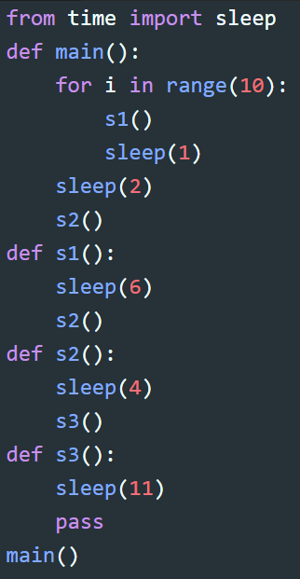
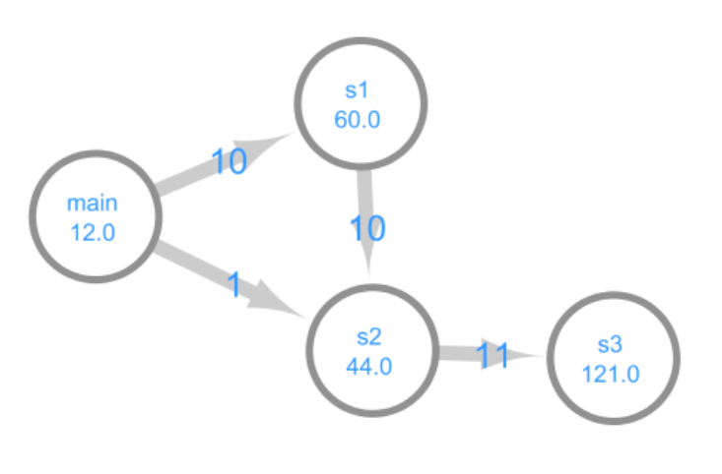

The arrows show which function called which. The weights on the edges show the number of times a function called another i.e. main called s1 10 times. The number under each function name shows the time spent solely in that function without it being in any other function i.e. if you look at the timings of main there are 10 1 second sleeps and 1 2 second sleep for a total of 12 seconds.

- Analysing call graph:
  - So that analysis can be run on the call graph a graph, node and edge class will exist to create the graph in the code. The graph class will contain all the nodes and the code to analyse the graph. The nodes will contain all their edges. It will be a directional graph with the edge recording the direction.
- Removing straight line connections in the graph
  - Graph algorithm described below will be used to remove any straight-line connections in the graph that do not branch.
- Cyclometric Complexity
  - This will be done by taking the call graph generated from the dynamic analysis and then looking for the number of paths through the network from the module node. The module node is designated as a function and refers to anything not inside any function.
  - This will consist of two separate algorithms. One algorithm needs to find out if the code is cyclic as if it is cyclic then you cannot calculate the Cyclometric Complexity of the graph. Then the second is the function that calculates the Cyclometric Complexity if the graph is not cyclic. The two key algorithms required for these functions are breadth first and depth first searching of the graph. The algorithms are described in more detail below.

Taking in information:

This will be done using two methods, the GUI and the excel spreadsheet.

- GUI
  - This will be done using a library called tkinter that will take in all relevant file locations
- Spreadsheet
  - This will be done by the user writing information into the spreadsheet and then that is taken in using the library openpyxl, apart from the information taken in above other information taken in will be the username of the user and their code preferences. This data will be stored in a linked sql table.
  - Users should also have the option to not input a spreadsheet meaning they do not have any input cases and just want the code analysed. This will then produce the Spreadsheet of analysed data and the graphs in the save location.

Saving of files:

Every file will be saved using the database class, graphs will have the type they are (Static or Dynamic), followed by a unique timestamp and spreadsheets will just be called the unique timestamp. Timestamps are used so that many repetitions of analysis do not overwrite each other. For all users this information will be stored in the table of all file locations of previously analysed graphs and spreadsheet results.

Editing and Running of code:

The target code is taken in and converted to a string. This allows the profiler software to modify the code and add whatever is necessary. The code can then be run using the exec command in python.

UML Diagram

Here is the UML diagram. There is the main GUI class which creates the main class. This class is the main analysis class which then starts the static analysis. This class creates lots of function classes, one for each function. Then main creates the dynamic analysis class which creates the input running class, these two classes then run and analyse the data. During the whole runtime there is the database class which all other classes talk to, to save their data. The function classes and database classes are aggregated to Dynamic Analysis, Input Running and Static Analyses as they all require those two classes.

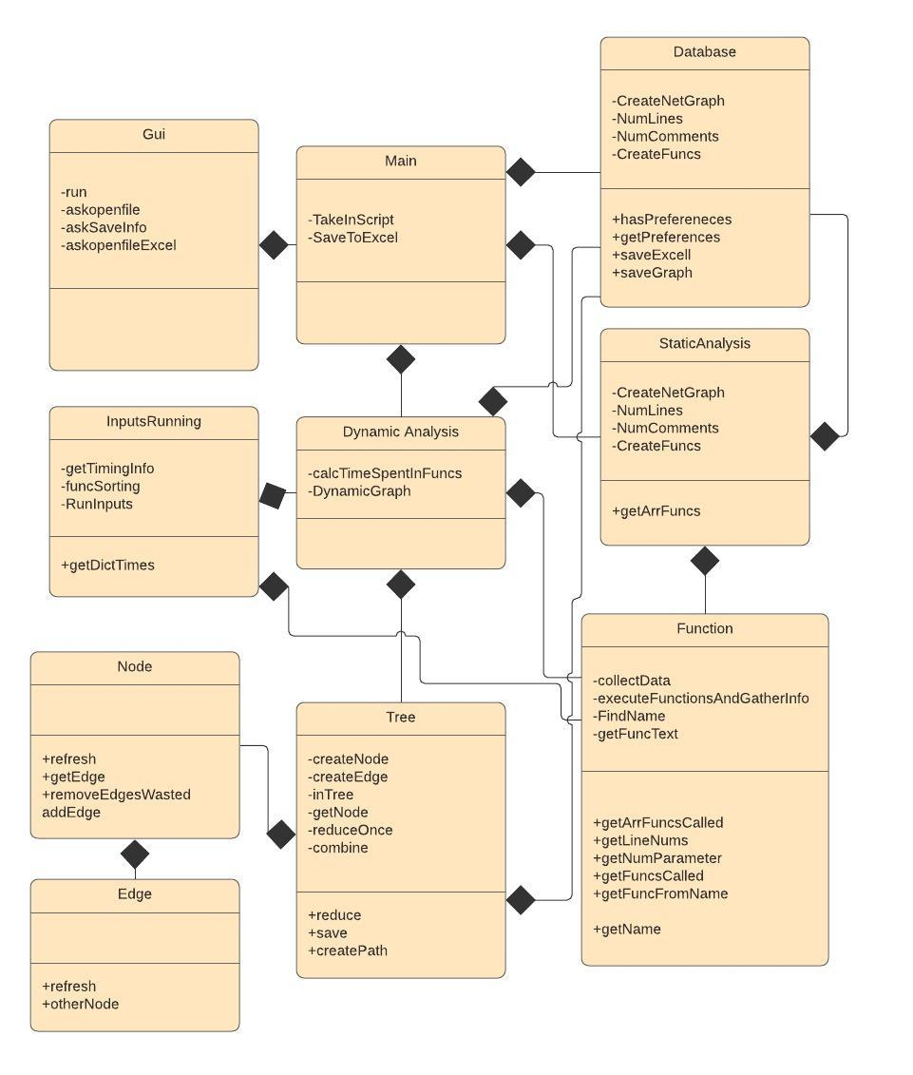

Algorithms
Data is collected on when each function calls the next function and when one function returns from the next. This information is stored in an array with timestamps. With each function call instance given a unique number to be identifiable. For example, for this piece of code:

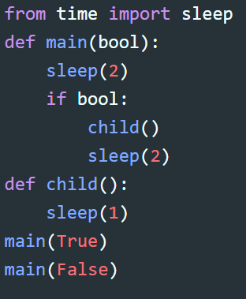

The array would look like this:

[(main1, 10),(child1, 12),(child1, 13),(main1,15),(main2,18),(main2, 20)]

This array shows that main is called first which calls child which doesn’t call any functions (This is known as there are no other function calls until child1 finished at time 13 so it couldn’t have called another function). Then main finishes then main is called again without calling any other functions. The aim of the algorithm is to work out how much time is spent within one function without it calling another. The algorithm does this by looping through the array looking for any consecutive function call instances meaning the function calls and returns without calling another function. It then works out the time spent in that function by subtracting the two timestamps and then joins the two items together replacing them with just one time. That time is added to the total time spent in that function. The new array would look like this: (Where the one represents the condensed child1 function call and return. The amount of time child function takes would then be increased by 1 second)

[(main1, 10),1,(main1,15),(main2,18),(main2, 20)]

This process repeats with the consecutive function call and returns. Also counting if they are just separated by times. If one is found such as main1 then it works out the return timestamp subtract start timestamp and then subtracts the sum of all the times inside. This totals to 4 seconds which would then be added on to the amount of time main took. Then everything from the start of main1 to its finish is then concatenated to the total time between the two which is 5 seconds as shown below:

[5,(main2,18),(main2,20)]

This algorithm then repeats until no function calls and returns are left. This algorithm has time complexity O(n²), this is because you need to loop through the array some number of times which is proportional to n and therefore the leading polynomial order would be n².

Removing stretches of straight line in the graph:

Explanation:

For example, if the call graph looks like this:

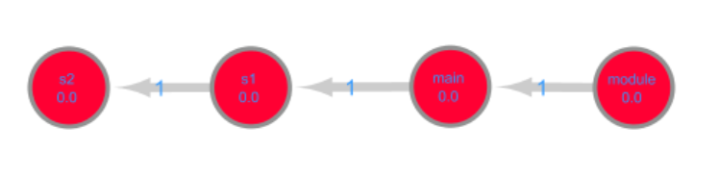
This could be compressed to just a single node and therefore as part of a bigger graph would be much easier to look over. It could be compressed to a single node showing the 4 names combined and the total time they took.

Another example:
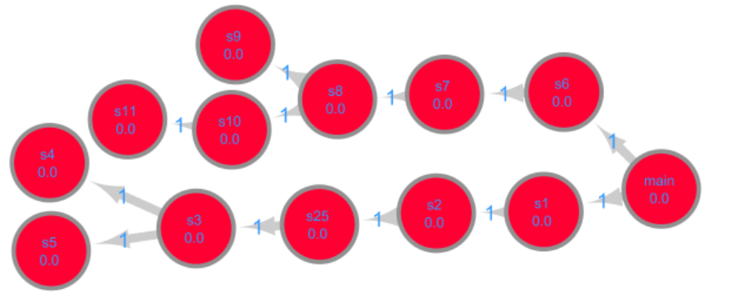
On this graph s6 and s7 should be combined. Also combine s1, s2 and s25 and finally also combine s11 and s10. This allows for a better overview of the graph without losing any branches. However you would not combine s7,s6,main,s1,s2,s25 because of the direction of the branches from main and that they do not go in the same direction and therefore information would be lost if compressed.

Algorithm:

The algorithm will work by looping through all the nodes and their children in a double for loop. For every pair of nodes, the first condition to check is that they both have 2 or less edges connected to them. This is the only non-unambiguous way to combine nodes. The next check is that the direction moves in the same direction through the nodes. This will be done by looking at the edge that connects node and child (ConnectorEdge) and, if it exists the edge that connects the node to another called otherEdge1 and the edge that connects child to another node called otherEdge2. The check will be to see whether otherEdge1 points to node and ConnectorEdge points to child and that otherEdge2 points away from child. If these 3 are satisfied, then the node and child can be compressed. The vice versa will be looked at when the child is the node and the node is the child in the for loop. Once two nodes are compressed and weights are summed this process can begin from the start. Once all possible combining is done the final graph will have been reduced.

Cyclometric Complexity

You first need to check if the graph is cyclic as if it is then it is not possible for the profiler software to calculate the number of paths through the graph as there are infinite. That is why two algorithms are necessary. One to check if it is cyclic and the second to calculate the number of paths.

Checking if Cyclic

This is an algorithm that checks if a directional graph is cyclic. If it is then that suggests there is recursion occurring in the code that is being analysed. Two dictionaries are used, one that stores which nodes have been visited and one that keeps track of which nodes have been passed in the depth first search called the recursion stack. The algorithm is made up of two functions. One function takes in a node and recursively calls itself on all forward connected nodes at this point these nodes are added to the visited and recursionStack. If the node is not found to have a cycle on that path, the node is removed from the recursionStack. The second function loops through all nodes that haven’t been visited calling the first function and if it ever returns True then the first function returns True. Here is the pseudocode.

def iscyclicSpecific(node,visited,stack):
#this node has now been visited and is placed on the recursion stack
Visited[node] = True
Stack[node] = True
#look at all forward connected neighbours
for neighbour in node.connectedToForwards():
#if neighbour been visited do not need to check again
if not visited[neighbour]:
if cyclicSpecific(neighbour, visited, stack):
return True
#if not visited but in recursion stack then there is a cycle
elif stack[neighbour]:
return True
#remove from path as this path has not leaded to any cycles
stack[node] = False
return False

def isCyclic():
#initialize visited and recursion stack dictionary
visited = {node:False for node in self.nodes}
stack = {node:False for node in self.nodes}
#loop through not visited nodes
for node in self.nodes:
if not visited[node]:
if isCyclicSpecific(node,visited,stack):
return True
#No cycles found
return False

Calculating Cyclometric Complexity

The aim of this algorithm is to start from the base node and calculate the number of paths through the graph. The main part of this algorithm will be a breadth first search. The software will start at the base node which will be the module node which calls the first function. From there the function will recursively call itself on all its children (where a child is a node that has a direction edge pointing from the node to it). Whenever a node has no more children, that is the base case and 1 is added to the total number of paths through the network. Here is some python to demonstrate the algorithm.

def CylcomComplexity(node):
numPaths = 0
#check if it has a child
done1 = 0
#look at all children
for child in node.children:
#there is at least one child
done1 = 1
#recursive step
numPaths += CyclomComplexity(child)
#if no child then number of paths should increase by one
if done1 == 0:
numPaths += 1
return numPaths

Adding to Code to input Code

One of the main additions to the code is the function definition of the decorator. A decorator in python works by placing @NameOfDecorator above a function and whenever that function is called the decorator is called first and you can wrap the function in some extra code. Here is some pseudocode for the decorator:

def funcDecorator(a_func):
# *args and **kwargs used to allow any number of parameters
def wrapTheFunctions(*args, **kwargs):
#As described above the second argument is the name of the function that is being called with the unique number placed after it
FuncName = args[1] + ' ' + str(DictNames[args[1]])
#The unique number for that function is incremented by one so the next time function is called it will have another unique number
DictNames[args[1]] += 1
#The array of timestamps has a tuple of the function name and the time it is called
Called.append(FuncName,time.time())
#Function is called with anything it returns saved in a placeholder variable
Placeholder = a_func(*args, **kwargs)
#Finishing time of the function recorded as the second timestamp
Called.append(FuncName,time.time())
#The first two arguments are used to increment the edge weight between the function in and function called by one in the dictionary
numTimesCalledDict[(args[0],args[1])] += 1
#the place holder is then returned.
return placeholder
return wrapTheFunctions

@funcDecorator will then be placed above all function calls to make sure that they are wrapped with this code whenever they are called. Other more basic code added is shown below:

#Import time library to work with the decorator
import time
#Initialize variables used
Called = []
#Append module 1 to the called array to record the start and stop of the whole code
Called.append(('module 1', time.time()))
#Define an array containing all the inputs for one specific batch of inputs
inputsxyzxyz = ['input1','input2','input3']
#Turn the array into a generator
inputsxyzxyz = (item for item in inputsxyzxyz)
#Create a function that will work instead of print to save variables that would be printed
def saveToVariable(toSave):
SavedOutputs.append(toSave)
#Turn the print function into the saveToVariable function
print = saveToVariable
#Create a function to operate instead of taking inputs
def getNextInputXYZ(*args,**kwargs):
#Returns the next item in the inputsxyzxyz generator
return inputsxyzxyz.__next__()
#Turns the input function into the getNextInputXYZ function
input = getNextInputXYZ

### At the end of the code writes the module 1 to the code again so code can record when the whole code finished.
Called.append(('module 1', time.time()))

You can see above the getNextInputXYZ and saveToVariable functions described earlier.

The final change needed is to add the function name currently in and the function calling into all function calls i.e. if in the code this is written:

def Start(a,b):
GetNext(a,b)

This should be replaced to

def Start(FuncIn,FuncCalling,a,b):
GetNext("Start","GetNext",a,b)

The arguments in the function calls also need to be updated to be able to take in the extra function parameters:

This will be done by looping through all function names and with a recursive regex statement to correctly match the brackets so that other cases are not picked up. The regex statement works by using the ?1 which places everything in the first capturing group back into where the ?1 is which allows it to locate any valid bracket pairings. The statement also makes sure to ignore any brackets that are within two quotation marks as they do not need to be matched. Here is what the loop will look like.

for name in FuncNames:
#Loop through all function names and look when they are followed by a legitimate bracket pairing
for index,m in enumerate(regex.finditer(name + r'(\(((((?1)|[^\(\)])|(\".*\"))|(\'.*\'))*\))', line)):

Here is a description of what will run inside the loop:

If it is a function call:

Within this loop the code will initially work out which function it is in by looking at the range of lines different functions take up using the Function Classes and finding all functions which the line is within and then taking the function which has it function definition the lowest down from these options as that must be the closest function the line is in. Therefore, that will be the function being called from and the name before the brackets will be the function calling and then these two will be placed as strings in the first two places in the arguments call.

If Function definition:

It will just write two placeholder variables as the first two parameters in the function definition as these will always be taken up.

This then allows the decorator to work out the function currently in and the one being called.

Data structures
Graph: Call graph will be used to look at how functions call each other. The edges will be directional showing which function called which. The nodes will also have weights to show the time spent in that function. The graph is represented in the code as several node classes which each contain a list of edge classes. This is what the graph output should look like:

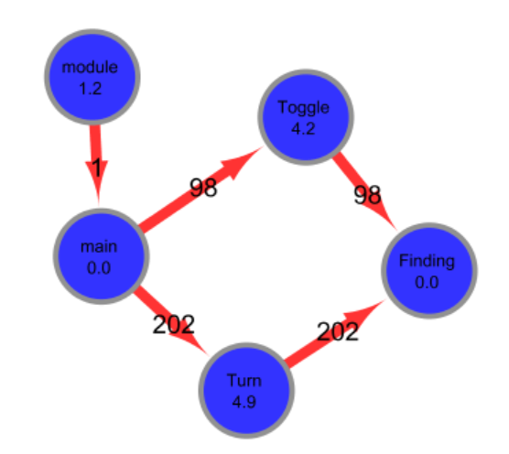

Other key data structures will be a list to store all the timestamps of the function calls. While the list is being added to it, it will function like a queue data structure as items are only ever added to the end of the list. However, when analysed it will operate as a list as it is being looped over several times and edited.

Dictionaries will also be used to store the number of times each function calls a function. Tuples will show which function called which as the first item will be the function calling and the second the function called. Tuples are used as they can be hashed and the dictionary’s keys will be these tuples with the item at each key being the number of times it is called. This allows incrementation at run time of number of calls to happen very fast.

File structure and organisation

The GUI asks the user where the files should be saved. All outputs from the file are then saved in this location. All filenames have timestamps. This allows the user to run many tests over the course of the codes development and they can look back at previous versions and compare the metrics obtained. All the locations of all the files for all the users are also saved in an sql table which the user can access if they need to find the location of a file made at a specific time.

Excel Input Format:

To add input data into your code:

This will work by taking the blank initial sheet and just adding columns for each batch of inputs for example if you wanted the first run to input 3 and hello and then the second to input good and job then you would put this into the spreadsheet:

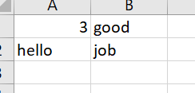

Leaving the sheet with the default name of Sheet1 to speed up the input process.
If you then wanted to add outputs required, you would add a new sheet called Outputs where you would place the number for the output batch increasing from one and then the outputs expected then leaving a gap in the columns placing the next batch. For example, if you were expecting bye and 3 for the first batch and for the second: hello and goodbye and for the third: fake and hat. You would fill it in like this:
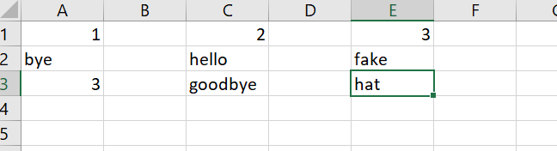

The colums after each outputs will then be filled in with the outputs obtained and highlighted if they do not match the outputs wanted.

If the user wants to add preferences then they can create a new sheet called Data and fill it in like the example given below:

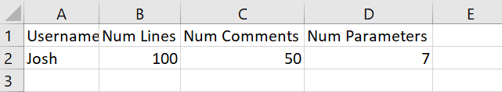

This shows their username is Josh and they do not want more than 100 lines, more than 50 comments and more than 7 parameters per function.

After you have input your preferences once you can just enter your name into the spreadsheet and it will remember you preferences from the SQL table.

After running the code, it will create two extra sheets called Static Data and Dynamic Data. The Static data sheet will contain all the statically analsed data and the Dynamic Data will contain the data about wether it is Cyclic and if not the number of paths through the code.

Database design
There will be a data structure where each user can store their preferences such as maximum comments, maximum length per line and number of parameters. Therefore, the data structure will have a primary key which is the user and have subsequent columns storing their preferences. This table will link to two other tables one which has the users previous Excel file locations alongside a foreign key of the Users Name and another which has all the users previous graph file locations alongside a foreign key of the Users Name.

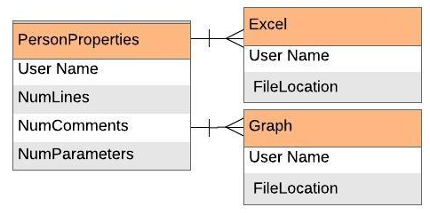

User interface design (HCI)

There will be a GUI which allows the user to select some code, spreadsheet and an output file and then a button to run the code which will always preform static and dynamic analysis. The GUI will then also let the reader know when the analysis is complete. It should look like below:

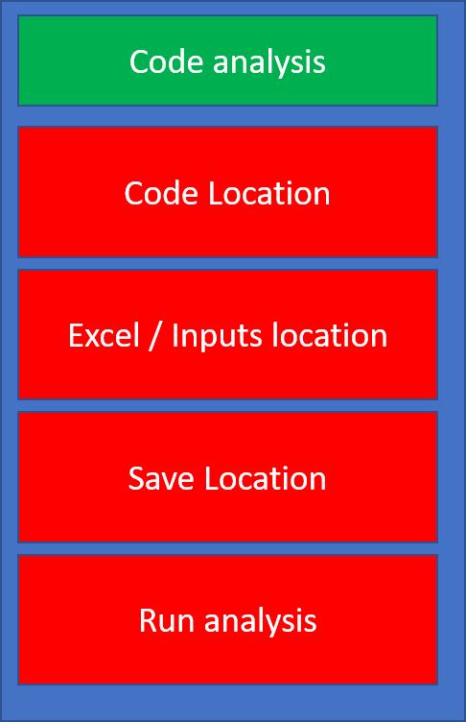

Technical Solution

Completeness Section

I believe I have met all my objectives and I believe the code works very effectively as a unit tester and analyser for software developers.

Objectives Revisited

Where objectives have been met they have been highlighted green in the code.

Technical Skills Section

Where these technical skills have been used they have been highlighted yellow in the code.

Graph:

I have an inbuilt graph data structure which is the Tree class. This class stores the dynamically analysed graph. The graph can then be analysed using my custom graph analysis code to compress any parts of the code which has no branches allowing for better viewing of the code. Depth first searching is also used to locate any cycles within the code. Breadth first search is also used to calculate the number of paths through the graph from a starting point.

Unravelling the array:

Another complex algorithm was the one to calculate the time spent solely in one function without it being in another as well. This required analysing the 1d array to unravel it and work out how much time was spent in each one. This algorithm also used list operations such as append, concatenate and list slicing

Aggregation and Dynamic Class creation:

I have used aggregation in the Static Analysis class as each function is aggregated to the main StaticAnalysis class. Aggregation is also used with the database class so that many different classes can access the database and save files. Aggregation is also used with the function classes as the static analysis class, input running class, and dynamic analysis classes all have access to the function classes.

Recursion and Regex:

To locate the function calls recursion was necessary so that the brackets could be correctly matched up. This was done using the regex library and the question mark with a number operator.

Recursion is also used in the breadth (calculating number of paths) and depth first (checking for any cycles) search of the graph.

Relational Database:

The python library sqlite3 was used to create and modify the database. Linked tables were used in the database with a one-to-many relationship between PersonProperties and Excel and another one-to-many relationship between PersonProperties and Graph. The Graph and Excel table had the foreign key of the userID and then the file location.

Hash Table

The dictionary data structure was used to store the number of calls between each function as this allowed quick access and edit properties.

Code listing

Code Listing

#Packages needed
import re
import regex
import pandas as pd
import numpy as np
import networkx as nx
import inspect
from tkinter import *
from tkinter import filedialog
from tkinter import messagebox
import time
import sys
import numpy as np
import sqlite3
import openpyxl as ex
from random import randint
from datetime import datetime

class Database:
#Database class which deals with saving all files and the sql table
def __init__(self,Excel):

#### Objective 18,19

#### Relational Database

#Creates overall table of usernames and their preferences if it does not yet exist
# Table only created if it does not yet exist
self.conn = sqlite3.connect('Storage.db')
stmt = """CREATE TABLE IF NOT EXISTS PersonProperties
(ID CHAR(50) PRIMARY KEY NOT NULL,
COMMENTS INT NOT NULL,
LINES INT NOT NULL,
ARGUMENTS INT NOT NULL);"""
self.conn.execute(stmt)
book = ex.load_workbook(Excel)

#Excel and graph tables initialized with their ID as the foregin KEY
#Of the PersonProperties table
stmt = """CREATE TABLE IF NOT EXISTS EXCEL
(ID CHAR(50) NOT NULL,
FILELOCATION CHAR(50) NOT NULL,
FOREIGN KEY(ID) REFERENCES PersonProperties(ID));"""

self.conn.execute(stmt)

stmt = """CREATE TABLE IF NOT EXISTS GRAPH
(ID CHAR(50) NOT NULL,
FILELOCATION CHAR(50) NOT NULL,
FOREIGN KEY(ID) REFERENCES PersonProperties(ID));"""

self.conn.execute(stmt)
#Inserts the persons preferences if they are in the Excel spreadsheet

self.name = None
if "Data" in book:
sheet = book["Data"]
Name = sheet.cell(row = 2,column = 1).value
self.name = Name

NumLines = sheet.cell(row = 2,column = 2).value
NumComments = sheet.cell(row = 2,column = 3).value
NumParameters = sheet.cell(row = 2,column = 4).value
DatabaseName = randint(100,1000)
query = """SELECT ID
FROM PersonProperties;"""
result = self.conn.execute(query)
result = [i[0] for i in result]
if self.name not in result:
stmt = f"""INSERT INTO PersonProperties(ID,COMMENTS,LINES,ARGUMENTS)
VALUES('{self.name}',{NumComments},{NumLines},{NumParameters})"""
self.conn.execute(stmt)
self.conn.commit()

self.getPreferences()

def hasPreferences(self):
if self.name is None:
return False
query = """SELECT ID
FROM PersonProperties;"""
result = self.conn.execute(query)
result = [i[0] for i in result]
if self.name in result:
return True
return False

def getPreferences(self):
query = """SELECT * FROM PersonProperties;"""

result = self.conn.execute(query)
for item in result:
if item[0] == self.name:
return item

def saveExcel(self,Excel,saveLocation):

#### Objective 11,23

#Unique timestamp produced
now = datetime.now()
book = ex.load_workbook(Excel)
#unique timestamp placed at the end of the name
book.save(saveLocation + "/" + (str(now).replace(":",";")).split(".")[0] +".xlsx")
loc = saveLocation + "/" + (str(now).replace(":",";")).split(".")[0] +".xlsx"
#location saved in the database

if self.name is not None:
stmt = f''' INSERT INTO EXCEL(ID, FILELOCATION)
VALUES('{self.name}','{loc}') '''

self.conn.execute(stmt)
self.conn.commit()

def saveGraph(self,DG,Name,location):
#same process for the graph as the spreadsheet just different file format
now = datetime.now()
timeAdd = (str(now).replace(":",";")).split(".")[0]
completeName = location + "/" + Name + timeAdd + "." + "graphml"
nx.write_graphml(DG,completeName)

if self.name is not None:
stmt = f''' INSERT INTO GRAPH (ID,FILELOCATION)
VALUES('{self.name}','{completeName}') '''

self.conn.execute(stmt)
self.conn.commit()

def Close(self):
self.conn.close()

class Main():

def __init__(self,CodeFile,saveLocation,Excel): # need to implement Excel = None
#If there is no spreadsheet input then it will create a spreadsheet where the code is run and then that spreadsheet will be saved at the saveLocation.
#The temporary spreadsheet is created in the program files of the code and is therefore hidden to the user
if Excel == None:
wb = ex.Workbook()
wb.create_sheet("Sheet1")
wb.save(filename = 'AnalysisResults.xlsx')
Excel = "AnalysisResults.xlsx"
#this called when run analysis button pressed on GUI
#first the database class is created
self.database = Database(Excel)
#Function to take in the script and convert it to text
self.TakeInScript(CodeFile)
#static analysis class is called and given inputs to use
Static = StaticAnalysis(self.script,saveLocation,Excel,self.database)
#function classes are obtained so that they can be passed to the dynamic analysis class
funcs = Static.getArrFuncs()
#Dynamic analysis class started with inputs given to run dynamic analysis
Dynamic = DynamicAnalysis(self.script,Excel,funcs,saveLocation,self.database)
#Final version after all editing done by different classes complete and database
#is then used to save it to the right location
self.database.saveExcel(Excel,saveLocation)
#all edits to database are saved and closed
self.database.Close()

def TakeInScript(self,location):
#Function that takes in the script and converts it to text
self.script = open(location,"r").read()

#Global function to remove comments as diffrerent classes need it
def removeComments(scriptorig):
script = ""
#all lines are looped through and only lines that
#dont start with a # are then added back in to the
#string which is then returned, if line contains
#code and comment then hastag is found and everything
#after is stripped from the script
for line in scriptorig.splitlines():
#obtain where first charachter is as
#there could be blankspaces first
commentstarts = len(line)-1
if commentstarts == -1:
continue
#locate where/if hashtag is
for index,let in enumerate(list(line)):
if let == "#":
commentstarts = index-1
break
#script appended to final script to be returned
#with anything after the hashtag removed
script = script + line[:commentstarts+1] + "\n"
return script

class StaticAnalysis():
#Orchestrates all the static analysis
# data collected = self.NumComments , self.NumLines,
def __init__(self,script,saveLocation,Excel,Database):
self.database = Database
self.saveLocation = saveLocation
self.script = script
self.scriptNoComments = removeComments(self.script)
#Create all function classes
self.CreateFuncs()
#Create the statc graph
self.CreateNetGraph()
#Get number of lines
self.NumLines()
#Get number of comments
self.NumComments()
#Save info to spreadsheet which has be found out
self.WriteUpInfo(Excel)

def WriteUpInfo(self,Excel):

#### Objective 10,20

#Excel spreadsheet loaded
book = ex.load_workbook(Excel)
#New sheet to save info created

try:
sheet2 = book["Static Data"]
except:
book.create_sheet("Static Data")
sheet2 = book["Static Data"]
#Headings created
NumLines = 10000000000
NumComments = 100000000000
NumParameters = 10000000000000000
redFill = ex.styles.PatternFill(start_color='FFFF0000',
end_color='FFFF0000',
fill_type='solid')
if self.database.hasPreferences():
name,NumLines,NumComments,NumParameters = self.database.getPreferences()
sheet2.cell(row = 1,column = 1).value = "Num Lines"
NLCELL = sheet2.cell(row = 2,column = 1)
NLCELL.value = self.NumLines
if NLCELL.value > NumLines:
NLCELL.fill = redFill
sheet2.cell(row = 1,column = 2).value = "Num Comments"
NCCELL = sheet2.cell(row = 2,column = 2)
NCCELL.value = self.NumComments
if NCCELL.value > NumComments:
NCCELL.fill = redFill
sheet2.cell(row = 1,column = 3).value = "Num Functions"
sheet2.cell(row = 2,column = 3).value = len(self.Funcs)
sheet2.cell(row = 1,column = 5).value = "Functions"
sheet2.cell(row = 1,column = 6).value = "Num Arguments"
sheet2.cell(row = 1,column = 7).value = "NumLocalVars"
sheet2.cell(row = 1,column = 8).value = "StackSize"
sheet2.cell(row = 1,column = 9).value = "Var Names"
sheet2.cell(row = 1,column = 10).value = "Num Lines"
counterRow = 2
counterCol = 5
#For each property of each function information saved
for func in self.Funcs:
sheet2.cell(row = counterRow,column = counterCol).value = func.getName()
counterRow += 1
counterRow = 2
counterCol += 1
for func in self.Funcs:
sheet2.cell(row = counterRow,column = counterCol).value = func.FuncInfoDict["NumArguments"]
if sheet2.cell(row = counterRow,column = counterCol).value > NumParameters:
sheet2.cell(row = counterRow,column = counterCol).fill = redFill
counterRow += 1
counterRow = 2
counterCol += 1
for func in self.Funcs:
sheet2.cell(row = counterRow,column = counterCol).value = func.FuncInfoDict["NumLocalVars"]
counterRow += 1
counterRow = 2
counterCol += 1
for func in self.Funcs:
sheet2.cell(row = counterRow,column = counterCol).value = func.FuncInfoDict["StackSize"]
counterRow += 1
counterRow = 2
counterCol += 1
for func in self.Funcs:
sheet2.cell(row = counterRow,column = counterCol).value = str(func.FuncInfoDict["varNames"])
counterRow += 1
counterRow = 2
counterCol += 1
for func in self.Funcs:
sheet2.cell(row = counterRow,column = counterCol).value = len(func.FuncText.splitlines())
counterRow += 1
#spreadsheet saved
book.save(Excel)

def getArrFuncs(self):
#Function to encapsulate the self.Funcs array
return self.Funcs

def CreateNetGraph(self):

#### Objective 21,22

#Function to convert the graph made up of Functions classes
#To a networkX graph which can be saved in the graphml format
DG = nx.DiGraph()
#Adds all functions as nodes to the graph
for Func in self.Funcs:
DG.add_node(Func.getName())
#add all edges by double looping through functions and their children
for Func in self.Funcs:
for child in Func.getArrFuncsCalled():
DG.add_edges_from([(Func.getName(),child.getName())])
#Graph saved through database class
self.database.saveGraph(DG,"StaticFuncInteracting",self.saveLocation)

def NumLines(self):

#### Objective 4

#Calculate number of lines by splitting script
#into a list with a line per item and using len function
self.NumLines = len((self.script.splitlines()))

def NumComments(self):

#### Objective 5

#looping through each line and adding one
#if there is a hashtag in the line
self.NumComments = 0
#Loop through all the lines in the script
for line in self.script.splitlines():
#Check if line has a hashtag
if "#" in line:
#Initialize variables such that no quotes have
#yet been opened
OpenSingle = 0
OpenDouble = 0
Correct = 0
#Loop through all charachters in the line
for char in line:
#If it is a single quote and it is not a
#open double quote then toggle the single quote variable
if char == "'" and OpenDouble == 0:
OpenSingle += 1
OpenSingle %= 2
#If it is a double quote and there is not a
#open single quote then toggle the double quote variable
if char == '"' and OpenSingle == 0:
OpenDouble += 1
OpenDouble %= 2
#If it is a # and not within any quotes then there is
#a comment
if char == "#" and OpenDouble == 0 and OpenSingle == 0:
Correct = 1
#Loop through rest of the line as there could be a valid
#and invalid hashtag symbol
#If there was a single valid hastag then add one to the number
#of comments
if Correct == 1:
self.NumComments += 1

def CreateFuncs(self):

#### Objective 6

#### Aggregation

#Creates a Function Object for every function in the script
self.Funcs = []
for index,line in enumerate(self.script.splitlines()):
line2 = line.strip()
#finds if first three charachters in a line is "def"
#Also works for functions in functions as it ignores indentations
# "def " used at the start of line used to make sure it definitely a function definition at the
#the line[0:4] checks it is at the start of the line as well. These two checks make sure only function definitions
#are found
if line2[0:4] == "def ":
#creates a function class adding it to is self.Funcs array
# giving the function the whole script and the line thats its defenition is on
self.Funcs.append(Function(self.script,index,self.scriptNoComments))
#Calls each function object to find out data about themselves
#Before each function can point to other function they all have to know their names
#Therefore FindName() funcion called first
for Func in self.Funcs:
Func.FindName()
#Then for all function data collecting function run to get information
for Func in self.Funcs:
Func.collectData(self.Funcs)

class Function():
#Class for every function in the script
def __init__(self,script,line,scriptNoComments):
self.scriptNoComments = scriptNoComments
self.script = script
self.line = line
self.scriptLines = self.script.splitlines()

def collectData(self,otherFuncs):
self.Defenition = self.scriptLines[self.line]
self.otherFuncs = otherFuncs
#works out what from the script is the functions text
self.FuncText = self.getFuncText()
#finds out what other functions are called
self.GetFuncsCalled()
#Get dynamic metrics by executing the Function
self.FuncInfoDict = self.executeFunctionAndGatherInfo(self.FuncText)
self.FuncInfoDict["Name"] = self.getName()

def getArrFuncsCalled(self):
return self.FuncsCalled

def executeFunctionAndGatherInfo(self,FuncText):

#### Objective 7,8,9

#This function gets information by creating the function within the
#class and then dynamically getting metrics on it such as size taken up

#function is executed
exec(FuncText,globals())
codeInfos = {"NumArguments":"argcount","NumLocalVars":"nlocals","StackSize":"stacksize","varNames":"varnames"}
FuncInfoDict = {}
for info in codeInfos:
#Certain property of the function found out
strEx = info + " = "+self.getName()+".__code__.co_" + codeInfos[info]
exec(strEx,globals(),FuncInfoDict)

return FuncInfoDict

def getLineNums(self):
#gives range of lines that function in so that code can decide what line is in which function
return (self.line,self.line + len(self.FuncText.splitlines())-1)

def getNumParameter(self):
#Encapsulator for num arguements item within FuncInfoDict
return self.FuncInfoDict["NumArguments"]

def GetFuncsCalled(self):
#Function to find out which functions are called by this function
self.FuncsCalled = set()
#Remove comments so easier to analyse
self.FuncTextNoCommas = removeComments(self.FuncText)
self.FuncLines = self.FuncText.splitlines()
FuncLines = self.FuncLines[1::]
names = [Func.getName() for Func in self.otherFuncs]

#Creates a regex statement to OR look for any function name
orString = "("
for item in names:
orString = orString + item + "|"
orString = orString[:-1]
orString = orString + ")"
OtherFuncCalls = []
for line in FuncLines:
#Regex run that is looking for any of the function names within this functions text
matches = re.finditer(orString+r'\(.*\)',line)
#Looping through all matches found
for i in matches:
OtherFuncCalls.append(i.group(0))
name = i.group(0).split("(")[0]
#function added to the FuncsCalled array by using the getFuncFromName function
#so that can point to actual class and not just the name
self.FuncsCalled.add(self.getFuncFromName(name,self.otherFuncs))

def getFuncFromName(self,Name,Funcs):
#Allows a function Class to be found from its name

#Loop through all function to find out which one has the same name
for Func in Funcs:
if Func.getName() == Name:
return Func
#Something has gone wrong if no func has been returned
#and therefore error raised
raise AssertionError("Func name can't be found")

def getFuncText(self):
#function to work out where the text of the function finishes

#First bit works out how many spaces before def in the first line
#of the function and therefore you know how many spaces you need before
#a charachter at the end of a function to know that the function text
#is finished
firstLine = list(self.scriptLines[self.line+1])
for index,let in enumerate(firstLine):
min = index
if let != " ":
break
finalLine = -1
#now looping through text looking for where spaces before charachter
#is smaller than or equal to one set up in earlier parr of the code
for index,line in enumerate(self.scriptLines[self.line+1::]):
for index2,let in enumerate(list(line)):
numspaces = index2
if let != " ":
break
#this checking for smaller then breaking as finalLine has been found
if numspaces < min:
finalLine = index + 1
break
#If no finalLine found the function goes until the end of the code
if finalLine == -1:
self.FuncText = "\n".join(self.scriptLines[self.line::])
else:
#Otherwise function text is from the start until finalLine
self.FuncText = "\n".join(self.scriptLines[self.line:finalLine+self.line])
firstLine = list(self.scriptLines[self.line])
for index,let in enumerate(firstLine):
min = index
if let != " ":
break
Function = ""
#Joining back funciton text together and returning
for line in self.FuncText.splitlines():
Function = Function + line[min::] + "\n"
return Function ###Check This

def FindName(self):
#Finds the name by splitting the definition
#and working out the text after def and before the (
self.Defenition = self.scriptLines[self.line]
self.name = self.Defenition.split()[1].split("(")[0]

def getName(self):
return self.name

class Tree:
#This is the graph class
def __init__(self):
self.nodes = []

def isCyclicSpecific(self,node,vis,stack):

#### Depth First Search & Recursion

#this node has now been visited and is placed on the recursion stack
vis[node] = True
stack[node] = True
#look at all forward connected neighbours
for neighbour in node.connectedToForwards():
#if neighbour been visited do not need to check
if not vis[neighbour]:
if self.isCyclicSpecific(neighbour,vis,stack):
return True
elif stack[neighbour]:
return True
stack[node] = False
return False
def isCyclic(self):

#### Objective 2

#have a visited dictionary to keep track of which nodes have been visited
vis = {node:False for node in self.nodes}
stack = {node:False for node in self.nodes}
#loop through all the nodes
for node in self.nodes:
#Only need to check if havent been visited
if not vis[node]:
if self.isCyclicSpecific(node,vis,stack):
return True
#If no cyclicness found return False
return False

def cyclomComplex(self,start):

#### Objective 29

#### Breadth First Search & Recursion

numPaths = 0
done1 = 0
for edge in start.edges:
if edge.node2 != start:
done1 = 1
numPaths += self.cyclomComplex(edge.node2)
if done1 == 0:
numPaths += 1
return numPaths

def save(self,saveLocation,Database):
#This function used to convert graph to networkX graph so that it can be saved
#as a graphml file
DG = nx.DiGraph()
#double loop through node and children
for node in self.nodes:
for child in node.connectedTo():
edge = node.getEdge(child)
if edge.node1 == node:
#weighted edge added and weight of node put as text under name so that it can be viewed in the GUI
DG.add_weighted_edges_from([(node.getName() + '\n' + str(node.weight),child.getName() + '\n' + str(child.weight),edge.weight)])
Database.saveGraph(DG,"ReducedDynamicFuncInteracting",saveLocation)
#nx.write_graphml(DG,saveLocation + "/ReducedDynamicFuncInteracting.graphml")

def createNode(self,node,weight):
#node createc with a certain weight
self.nodes.append(Node(node,weight))

def createPath(self,node1,weight1,node2,weight2,edgeWeight):
#weighted edge creation nodes also created if
#they dont exist
if not self.inTree(node1):
self.nodes.append(Node(node1,weight1))
if not self.inTree(node2):
self.nodes.append(Node(node2,weight2))
self.createEdge(node1,node2,edgeWeight)

def createEdge(self,node1,node2,edge):
#Edge class created between two nodes with its weight
node1 = self.getNode(node1)
node2 = self.getNode(node2)
edge = Edge(node1,node2,edge)
node1.addEdge(edge)
node2.addEdge(edge)

def inTree(self,nodeN):
#Check if a node is in a tree and either returning
#True or False
for node in self.nodes:
if node.getName() == nodeN:
return True
return False

def getNode(self,nodeN):
#Node object based on name is found and returned
if nodeN == "module":
for node in self.nodes:
if "module" in node.getName():
return node
for node in self.nodes:
if node.getName() == nodeN:
return node

def reduceOnce(self):
#One pair that can be reduced is found reduced and then function finishes
#If no pair found True is returned to show that graph is fully reduced

#Double loop through nodes and their children
for node in self.nodes:
for child in node.connectedTo():
#Check to see both node,child have 2 or less nodes
#which is a requirement for compressing
if node.numChildren() <= 2 and child.numChildren() <= 2:
#If they both only have one node they can always be combines
#irrespective of the direction
if node.numChildren() == 1 and child.numChildren() == 1:
#Combine function of the two nodes and then exit with False
#as other pair could still exist
self.combine(node,child)
return False
#if node has one, of course if child has then this will be checked later on in the loop
#at this point if node has 1 child then the child must have 2
if node.numChildren() == 1:
#OtherEdge and connectorEdge located of the child
for edge in child.edges:
if node in edge.nodes and child in edge.nodes:
connectorEdge = edge
else:
otherEdge = edge

#Check to see direction is in one way as described in the NEA writeup
if otherEdge.node2 == child and connectorEdge.node2 == node or otherEdge.node1 == child and connectorEdge.node1 == node:
#Combined
self.combine(node,child)
return False
#Final scenario if they both have 2
if node.numChildren() == 2 and child.numChildren() == 2:
#otherEdge and connectorEdge must be located for both node and child
for edge in child.edges:
if node in edge.nodes and child in edge.nodes:
connectorEdge = edge
else:
otherEdge = edge
for edge in node.edges:
if node in edge.nodes and child in edge.nodes:
connectorEdge2 = edge
else:
otherEdge2 = edge
#check if direction all in the same way
if otherEdge.node2 == child and connectorEdge.node2 == node and otherEdge2.node1 == node or otherEdge.node1 == child and connectorEdge.node1 == node and otherEdge2.node2 == node:
self.combine(node,child)
return False

#If got to here no pairs found so graph fully reduced
return True

def reduce(self):

#### Objective 28

#Function to reduce works by repeatedly calling reduceOnce()
#until it returns True showing graph fully reduced
while not self.reduceOnce():
#any edges that now dont have nodes on both sides becuase
#one side has been combined are deleted
for node in self.nodes:
node.removeEdgesWasted(self.nodes)

def combine(self,node1,node2):
#Function to combine two nodes as they have been found combinable

#first two nodes are removed from the nodes array
self.nodes.remove(node1)
self.nodes.remove(node2)
#name of new node created by putting a ',' in between the two names
newName = node1.getName() + "," + node2.getName()
#combined node created
self.createNode(newName,node1.weight+node2.weight)
combinedNode = self.getNode(newName)
#edge in original node1 that combines node1 with node2 is removed
#this also happens with node2
for edge in node1.edges:
if node2 in edge.nodes:
node1.edges.remove(edge)
for edge in node2.edges:
if node1 in edge.nodes:
node2.edges.remove(edge)
#edges in node1 and node2 updated so that instead of pointing to node1
#or node2 they point to the combined node
for edge in node1.edges:
if edge.node1 == node1:
edge.node1 = combinedNode
edge.nodes[0] = combinedNode
if edge.node2 == node1:
edge.node2 = combinedNode
edge.nodes[1] = combinedNode
for edge in node2.edges:
if edge.node1 == node2:
edge.node1 = combinedNode
edge.nodes[0] = combinedNode
if edge.node2 == node2:
edge.node2 = combinedNode
edge.nodes[1] = combinedNode
#the edges of the combined nodes are now just the edges of node1 and node2
combinedNode.edges = node1.edges + node2.edges
#for all other nodes if they pointed to node1 or node2 now need to point to the
# combined node
for node in self.nodes:
node.refresh(node1,node2,combinedNode)

def __repr__(self):
#for debugging if graph printed it should print a list of the nodes
return str(self.nodes)

class Edge:
#Edge class which houses the weight and the two nodes it connects
def __init__(self,node1,node2,edge):
self.weight = edge
self.node1 = node1
self.node2 = node2
self.nodes = [node1,node2]

def refresh(self,node1,node2,combinedNode):
#if nodes being combined this replaces the pointer to node1 or node2 with the combined
#node
if self.node1 == node1 or self.node1 == node2:
self.node1 == combinedNode
self.nodes[0] = combinedNode
if self.node2 == node1 or self.node2 == node2:
self.node2 = combinedNode
self.nodes[1] = combinedNode

def otherNode(self,nodeGot):
#if want to know from one node where it points to this returns
#the other node
if nodeGot == self.node1:
return self.node2
return self.node1

def __repr__(self):
#for debugging prints the first node and the second node and then the weight
return f"{self.node1.getName()} to {self.node2.getName()} with weight {self.weight}"

class Node:
def __init__(self,name,weight):
self.name = name
self.weight = weight
self.edges = []

def refresh(self,node1,node2,combinedNode):
#looks at all edges and if node1 or node2 in edges
#replaces them with the combinedNode
for edge in self.edges:
edge.refresh(node1,node2,combinedNode)

def getEdge(self,node):
#Find a certain edge connecting to a certain node
for edge in self.edges:
if node in edge.nodes:
return edge

def removeEdgesWasted(self,nodes):
#removes an edge if now no longer connects to valid node
edgesToRemove = []
for edge in self.edges:
if edge.node1 not in nodes or edge.node2 not in nodes:
edgesToRemove.append(edge)
for edge in edgesToRemove:
self.edges.remove(edge)

def addEdge(self,edge):
#adds an edge to its array of edges
self.edges.append(edge)

def getName(self):
#function to encapsulate self.name
return self.name

def connectedTo(self):
#returns all children node connecting to
children = []
for edge in self.edges:
children.append(edge.otherNode(self))
return children

def connectedToForwards(self):
#returns all children node connecting to
children = []
for edge in self.edges:
if edge.node1 == self:
children.append(edge.otherNode(self))
return children

def numChildren(self):
#each edge connects to a child and therefore length of
#edges is the number of children
return len(self.edges)

def __repr__(self):
#for debugging to print the node it first prints the name
#then the weight and then a list of its edges
return f"Name : {self.name} Weight : {self.weight} Edges : {self.edges}"

class DynamicAnalysis:
#Class for dynamic analysis
def __init__(self,script,Excel,funcs,saveLocation,Database):
self.database = Database
self.saveLocation = saveLocation
#First inputs must be run on the code and data collected
self.InputsRun = InputRunning(script,Excel,funcs)
self.excel = Excel
#data collected from the InputsRunC Class
self.path = self.InputsRun.getTimingInfo()
self.PathsUsed = self.InputsRun.getdDictTimes()
self.FuncCallSheet = self.InputsRun.FuncCallSheet
self.dictNumRanTimes = self.InputsRun.numTimesCalledDictarr[0]
self.TimesTaken = self.InputsRun.timesTaken
self.Funcs = funcs
self.numFuncsCalled = self.InputsRun.numFuncsCalled
self.times = self.calcTimeSpentInFuncs(self.FuncCallSheet,funcs)
#Graph created
self.DyanmicGraph()
#Outputs from inpts saved in excel
self.FillOutput(self.InputsRun.SavedOutputs,Excel)

def FillOutput(self,outputs,Excel):

#### Objective 16,17

#The colour to highlight any outputs that are wrong
redFill = ex.styles.PatternFill(start_color='FFFF0000',
end_color='FFFF0000',
fill_type='solid')
#Load in spreadsheet
book = ex.load_workbook(Excel)
try:
sheet2 = book['Outputs']
except:
book.create_sheet('Outputs')
sheet2 = book['Outputs']
counter = 0
#loop through all batch of outputs
for index,outputlist in enumerate(outputs):
counter += 2
#loop through each actual output and add to spreadsheet
for index2,output in enumerate(outputlist):
#method to acces the spreadsheet as a 2d array
cell = sheet2.cell(row = index2+2,column = counter)
cell.value = output
#if output does not match wanted output it is highlighted red
prevCell = sheet2.cell(row = index2+2,column = counter-1)
if cell.value != prevCell.value:
cell.fill = redFill
#spreadsheet saved
book.save(Excel)

def calcTimeSpentInFuncs(self,FuncCallSheet,funcs):

#### Objective 25

##### Unravelling the matrix

#Algorithm to calculate the time spent solely in one function without it being in another
#Creating a dictionary of the final times which will then be added to over the course of the function
times = {i.getName() : 0 for i in funcs}
times["module"] = 0
start = time.time()
#Func call sheet looped through which is a 2d array containing one array for each runtime
for index,q in enumerate(FuncCallSheet):
numFuncsHere = self.numFuncsCalled[index]
numFuncsConcated = 0
l = np.array(q)
counter = 1
indexStarted = 0
timeToSub = 0
#FuncLookingAt always the last function to have been seen while looping through the array
FuncLookingAt = l[0][0]
timeStarted = float(l[0][1])
while True:
#Check if function and not just to show some amount of time
#Always keeps track of last function come into contact with and looking for a time comes into closing
#of same function without any other functions being called inbtween
if l[counter][0] != "NOTFUNC" and l[counter][0] == FuncLookingAt:
numFuncsConcated += 1
timeFinished = float(l[counter][1])
times[l[counter][0].split()[0]] += ((timeFinished - timeStarted) - timeToSub)
timeToSub = 0
#Array is concatenated with everything inbetween function call and finish being replaced
# with just one time to show how long that bit took
l = np.concatenate((l[0:indexStarted], [["NOTFUNC",timeFinished - timeStarted]], l[counter+1:]))
counter = 0
#Skips over times to find next function call
while counter < len(l) and l[counter][0] == "NOTFUNC":
counter += 1
if counter >= len(l):
#if end reached then list has been fully concatenated and while loop can be exited
break
#as concateneted counter returns to the start
indexStarted = counter
timeToSub = 0
FuncLookingAt = l[counter][0]
timeStarted = float(l[counter][1])
#if could not match and is a function then that becomes the new FuncLookingAt
elif l[counter][0] != "NOTFUNC":
FuncLookingAt = l[counter][0]
indexStarted = counter
timeStarted = float(l[counter][1])
timeToSub = 0
#if it was just a time FuncLookingAt stays the same but total time increases by the time in the item
else:
timeToSub += float(l[counter][1])
counter += 1
if counter >= len(l):
break
return times

def DyanmicGraph(self):

#### Objective 27

#Dynamic graph created
DG = nx.DiGraph()
for i in self.PathsUsed:
DG.add_edges_from([(i[0] + '\n' + str(round(self.times[i[0]],1)),i[1] + '\n' + str(round(self.times[i[1]],1)))])
for i in self.dictNumRanTimes:
DG.add_weighted_edges_from([(i[0] + '\n' + str(round(self.times[i[0]],1)),i[1] + '\n' + str(round(self.times[i[1]],1)),round(self.dictNumRanTimes[i],1))])

self.database.saveGraph(DG,"DynamicFuncInteracting",self.saveLocation)
self.DynamicFuncInteracting = DG

#From data the graph class is also created
self.myTree = Tree()
for i in self.dictNumRanTimes:
self.myTree.createPath(i[0],round(self.times[i[0]],1),i[1],round(self.times[i[1]],1),round(self.dictNumRanTimes[i],1))
#reduce run on graph class to make it easier to view
self.myTree.reduce()
book = ex.load_workbook(self.excel)
#New sheet to save info created
try:
sheet2 = book["Dynamic Data"]
except:
book.create_sheet("Dynamic Data")
sheet2 = book["Dynamic Data"]
sheet2.cell(row = 1,column = 1).value = "isCyclic"
isCyclic = self.myTree.isCyclic()
sheet2.cell(row = 2,column = 1).value = str(isCyclic)
if not isCyclic:
module = self.myTree.getNode("module")
cyclomComplex = self.myTree.cyclomComplex(module)
sheet2.cell(row = 1,column = 2).value = "cyclomComplex"
sheet2.cell(row = 2,column = 2).value = str(cyclomComplex)
book.save(self.excel)
#New reduced graph also saved
self.myTree.save(self.saveLocation,self.database)

class InputRunning():
#class that runs the input and dynamically collects data
def __init__(self,script,excelFile,Funcs):

self.excelFile = excelFile
self.Funcs = Funcs
self.script = script
#If no input data code just run 10 times

#### Objective 12

self.inputData = [[None for j in range(10)] for i in range(10)]
#If there is an excel file the input data collected
if excelFile is not None:
self.inputData = []
book = ex.load_workbook(excelFile)
sheet1 = book['Sheet1']
col = 1
while True:
cell = sheet1.cell(row = 1,column = col)
#if cell value none then end of all inputs reached
if cell.value is None:
break
#placeholder contains all inputs for one batch and then appended to the inputData
placeholder = []
ro = 1
while True:
cell = sheet1.cell(row = ro,column = col)
#if cell value None then end of this input batch reached
if cell.value is None:
break
#to input blank user must write "" so that it can be distuigshed from the end which is nothing
if cell.value == '""':
placeholder.append("")
else:
placeholder.append(cell.value)
ro += 1
self.inputData.append(placeholder)
col += 1
#when inputs collected code is run
self.RunInputs(self.script,self.inputData)

def getTimingInfo(self):
#encapsulating self.paths
return self.paths

def getdDictTimes(self):
#encapsulating dictTimesArr
return self.dictTimesArr[0]

def funcSorting(self,script,funcs):

#### Objective 24,26

script2 = ""
for lineNum,line in enumerate(script.splitlines()):
for i in funcs:
if i.getName() in line:
numAdded = 0
#The recursive regex command to find all function calls for a certain function

#### Recursive Regex

for index,m in enumerate(regex.finditer(i.getName() + r'(\(((((?1)|[^\(\)])|(\".*\"))|(\'.*\'))*\))', line)):
end = m.span()[0] + len(i.getName()) + 2

if line.lstrip()[0:4] == "def ":
#Adds the arguments to all functions to accept to extra arguements, what function called it and This
#function
if i.getNumParameter() > 0:
line = line[0:end-1] + "FuncName,ThisFunc," + line[end-1::]
else:
line = line[0:end-1] + "FuncName,ThisFunc" + line[end-1::]
else:
#Works out which function a function call is in
#it does this by getting the range of lines each function is in
#and getting the one that has its start closes to the function call
minlines = 100000
winningFunc = 0
for z in funcs:
if lineNum > z.getLineNums()[0] and lineNum <= z.getLineNums()[1]:
numLines = z.getLineNums()[1] - z.getLineNums()[0]
if numLines < minlines:
minlines = numLines
winningFunc = z
#if no function around call then module is calling it
if winningFunc == 0:
winningFunc = f"'module','{i.getName()}'"
#winning function name and name of function is put in as two extra parameters to the start
#of the function call
else:
winningFunc = "'" + winningFunc.getName() + "'" +"," + "'" + i.getName() + "'"
if i.getNumParameter() > 0:
line = line[0:end-1 + numAdded] + winningFunc + ',' + line[numAdded + end-1::]
numAdded += 1 + len(winningFunc)
else:
line = line[0:end-1 + numAdded] + winningFunc + line[numAdded + end-1::]
numAdded += len(winningFunc)

script2 = script2 + line + "\n"
return script2

def RunInputs(self,script,inputs):

#### Objective 13,14,15,24,26

#function that runs the inputs
self.prints = print
#puts the two extra parameters to all the functions
script = self.funcSorting(script,self.Funcs)
#Regex to add the decorator to the top of all the funtion definitions
AddingDecor = regex.compile(r"(( )*def )")
scriptWithInputs = AddingDecor.sub("\\2\\2\\2\\2@funcDecorator\n\\1",script)
dictOfName = {i.getName():0 for i in self.Funcs}
dictOfName["module"] = 0
#text that is added to the code which includes the decorator function definition
#and the definition of some variables
decorString = """import inspect
import time
times = []
numFuncs = 0
def funcDecorator(a_func):
def wrapTheFunction(*args, **kwargs):
global numFuncs
numFuncs += 1
FuncName = args[1] + " " + str(DictNames[args[1]])
DictNames[args[1]] += 1
#adding start timestamp to the array
called.append((FuncName,time.time()))
placeholder = a_func(*args, **kwargs)
#adding finishing timestamp to the array
called.append((FuncName,time.time()))

#### Hash Table

dicts.add((args[0],args[1]))
#incremeting number of times this func called another by one
if (args[0],args[1]) in numTimesCalledDict:
numTimesCalledDict[(args[0],args[1])] += 1
else:
numTimesCalledDict[(args[0],args[1])] = 1
return placeholder
return wrapTheFunction"""

decorString = "DictNames = " + str(dictOfName) + "\n" + decorString
#adding decorstring to script that will run
scriptWithInputs = decorString + "\n" + scriptWithInputs
strtest = """SavedOutputs = []
dicts = set()
numTimesCalledDict = {}
#function to save variables
def saveToVariable(toSave):
SavedOutputs.append(toSave)
#function to print is replaced with a function that will save whatever
#was meant to be printed
print = saveToVariable
def getNextInputXYZ(*args,**kwargs):
return inputsxyzxyz.__next__()
input = getNextInputXYZ"""
exec(strtest,globals())
global numTimesCalledDict
global dicts
self.paths = []
self.FuncCallSheet = []
self.timesTaken = []
self.numFuncsCalled = []
self.numTimesCalledDictarr = []
self.dictTimesArr = []
self.SavedOutputs = []
#for each batch of inputs code is run
if len(inputs) == 0:
inputs = [[1]]
for input in inputs:
#this specific input must be added as generator to the start of the code
strToExec = "inputsxyzxyz = " + str(input)
strToExec2 = "inputsxyzxyz = (item for item in inputsxyzxyz)"
totString = strToExec + "\n" + strToExec2 + "\n" + scriptWithInputs
starttime = time.time()
totString = "import time" + "\n" + "called = []" + "\n" + "called.append(('module 1',time.time()))" + "\n" + totString + "\n" + "called.append(('module 1',time.time()))"
#code is actually run
exec(totString,globals())
self.timesTaken.append(time.time()-starttime)
global times
#data is recorded and saved to the classes variables
self.paths.append(times)
self.FuncCallSheet.append(called)
self.numFuncsCalled.append(numFuncs)
self.numTimesCalledDictarr.append(dict(numTimesCalledDict))
self.dictTimesArr.append(set(dicts))
numTimesCalledDict = {}
dicts = set()
SavedOutputs.append("SPLIT")
self.SavedOutputs = self.splitOutputs(SavedOutputs)

def splitOutputs(self,SavedOutputs):
#saved outputs is split up so that for each set of inputs
#we have the corresponding set
self.SavedOutputs = []
placeholder = []
for item in SavedOutputs:
if item != "SPLIT":
placeholder.append(item)
else:
self.SavedOutputs.append(placeholder)
placeholder = []
return self.SavedOutputs

class GUI:
#GUI Class
def __init__(self):
self.ExcelFile = None
self.saveLocation = None
self.root = Tk()
frame = Frame(self.root)
frame.pack()
self.root.title("Software Analyser")
self.root.iconbitmap("GraphSquareSmall.ico")
#Creating the buttons
bottomframe = Frame(self.root)
CodeFile = Button(frame, text = 'Find Code File', fg='brown',width = '25', command = self.askopenfile)
CodeFile.pack( side = TOP )
ExcelFile = Button(frame, text = 'Find Excel File', fg='brown',width = '25', command = self.askopenfileExcel)
ExcelFile.pack( side = TOP )
SaveLocation = Button(frame, text = 'Which folder to save?', fg='brown',width = '25', command = self.askSaveInfo)
SaveLocation.pack( side = TOP )
bottomframe.pack( side = BOTTOM )
RunButton = Button(frame, text = 'Run Analysis', fg ='red',width = '25', command = self.run)
RunButton.pack( side = TOP)

self.root.mainloop()

def run(self):
#Creating main class when run button pressed
messagebox.showinfo("Analysis started","The analysis of your code has begun")
mains = Main(self.CodeFile,self.saveLocation,self.ExcelFile)
messagebox.showinfo("Analysis complete","The analysis of your code is completed please view all files in the file you saved them")

def askopenfile(self):

#### Objective 1

#Get code location
self.CodeFile = filedialog.askopenfile(mode = 'r').name

def askopenfileExcel(self):

#### Objective 2

#get Excel location
self.ExcelFile = filedialog.askopenfile(mode = 'r').name

def askSaveInfo(self):

#### Objective 3

#get save location information
self.saveLocation = filedialog.askdirectory()

Gprint = print
sys.setrecursionlimit(3000)
myGUI = GUI()

System testing

Test plan

All code used for testing purposes are placed in the appendix.

Test number | Purpose of test | Test data | Expected outcome | Result
1 | GUI can take in a script |  | File should be taken in and should return to GUI | Pass
2 | GUI can take in spreadsheet |  | Spreadsheet should be taken in and should return to GUI | Pass
3 | GUI can take in a save location |  | Save location should be taken in and should return to GUI | Pass
4 | Check software can calculate number of lines | Testscript.py | Number of lines in testcript.py should be written in the spreadsheet | Pass
5 | Check software can calculate number of comment lines | Testscript.py | Number of comments should be written in the spreadsheet | Pass
6 | Check software can calculate the number of functions | TestScript.py | Number of functions should be written in the spreadsheet | pass
7 | Check software can find the number of parameters | Testscript.py | Number of parameters for each function should be written in spreadsheet | Pass
8 | Check software can find the number of local variables in each function | Testscript.py | Number of local variables for each function should be written in the spreadsheet | Pass
9 | Check software can find all local variables for each function | Testscript.py | Names of all local variables for each function written in spreadsheet | Pass
10 | Check software can edit spreadsheet | Testscript.py | Check spreadsheet edited | Pass
11 | Check spreadsheet saved in the correct place | Testscript.py | Check spreadsheet saved where save location was told | Pass
12 | Check software can read inputs from the spreadsheet | Testinputs.py | Check code can print the inputs from the spreadsheet | Pass
13 | Check software can alter code to run inputs | Testinputs.py | Looking at printed version of testinputs.py it should be modified to allow for the inputs | Pass
14 | Check software can run code and that prints from code are due to the inputs | Testinputs.py | Prints from code should be due to inputs in the spreadsheet | Pass
15 | Check outputs are saved in the spreadsheet | Testinputs.py | Check code file modified to record outputs | pass
16 | Check outputs recorded in spreadsheet | Testinputs.py | Check spreadsheet contains the outputs that should be there due to the inputs | Pass
17 | Check incorrect outputs highlighted | Testinputs.py | Check any outputs in the spreadsheet that do not match outputs wanted are highlighted | Pass
18,19 | Check user preferences taken in and recorded in sql table | testExcel.xlsx | Check sql table has the preferences from the spreadsheet | Pass
20 | Check software highlights when code does not hit preferences | Testscript.py | Check spreadsheet metrics highlighted if higher than the preferences of the specific user | Pass
21,22 | Check call graph can be generated | Testscript.py | Check a graph is saved with extension graphml and can be viewed using the appropriate software | Pass
23 | Check software stores all previous spreadsheets and graph locations | Testscript.py | After running with testscript.py a few times look at sql table to see if save locations recorded | Pass
24 | Check code is edited to include decorators | Testscript.py | Check code printed that has been edited to check decorators added | Pass
25 | Check code can collect times of functions | Testscript.py | Final graph generated should contain the times | Pass
26 | Check function can calculate number of times each function calls another | Testscript.py | Final graph should have weighted edges showing number of times each path activated | Pass
27 | Check a call graph is saved and generated | Testscript.py | Check a graph is saved that can be opened using the appropriate data showing a call graph | Pass
28 | Check graph can be condensed correctly | reducingtest.py | Check that the dynamimc graph vs the reduced dynamic graph has been correctly reduced | pass
29a | Check software can work out if graph is cyclic or not | notCyclic.py  Cyclic.py | In spreadsheet it should show notcyclictest.py isn’t cyclic and Cyclictest.py is cyclic | pass
29b | Check software can calculate the cyclometric complexity of the code | notCyclic.py | In spreadsheet it should show the cyclometric complexity | pass

Annotated screenshots of test results

Test: 1,2,3

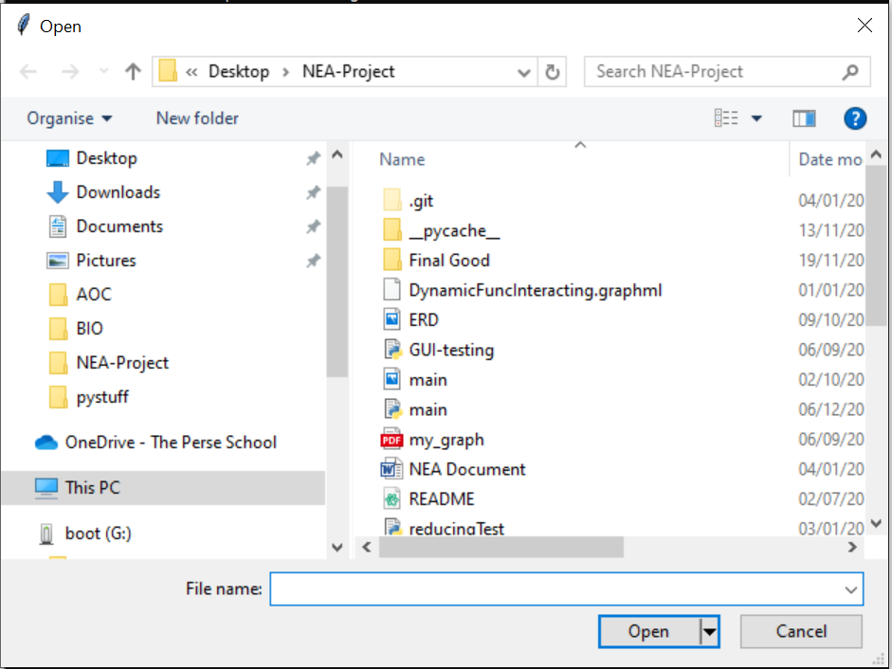
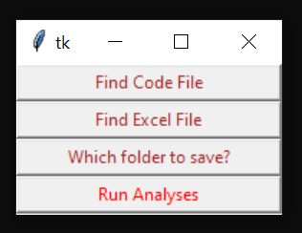

This is what it looks like for test 1,2,3. On the left is the gui and when one of the first 3 pressed the window on the right pops up takes in a file or a folder then closes returning to the GUI.

Test 4,5,6

Testscript.py is a long file that does lots of processing to properly test the software.

Testscript.py is a file with 360 lines 5 comments and 7 functions. In the spreadsheet, it looks like this:

TestScript.py also contains this line:

print(“#this is not an actual’ comment”)

Which tries to catch out the computer to include it as a comment when it isn’t and there are 5 actual comments in the code and this line and you can see this line was not included in the number of comments so it correctly identified it was not a comment.

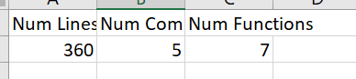

Test 7,8,9,10,11:

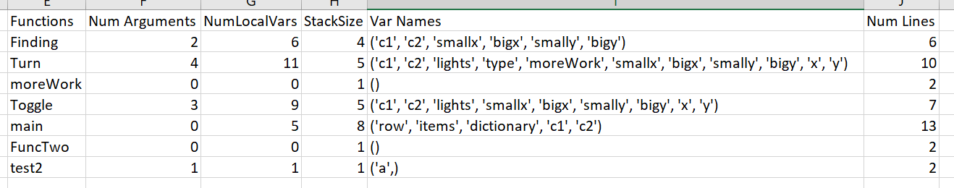

This data is correct with respect to testscript.py and is shown in the spreadsheet. The spreadsheet was also saved where I indicated earlier the save location should be

Test 12:

Here is testinput.py to test the input output part of the software:

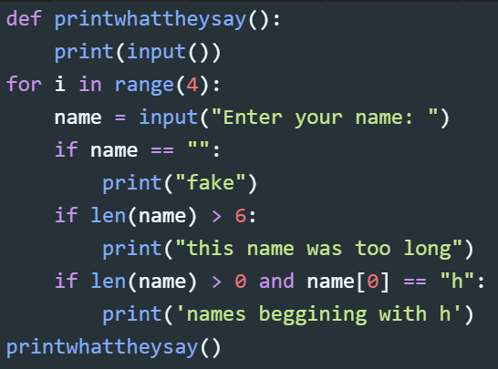

These are the inputs in the spreadsheet:
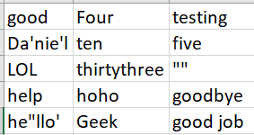
They are also the same from the printed code showing it was taken in correctly
As you can see it doesn’t matter if quotes or double quotes used in input as they are correctly taken from the table. You can see if only single quotes used then it is placed in double quotes and if both are used then backslash placed after quote so that it is not registered.

Test 13,14,15,16:

These were the inputs to the inputtest.py script (where the “” means that the input is nothing):

Running the code manually I know the output should be

Inputs 1 | Inputs 2 | Inputs 3
this name was too long | this name was too long | this name was too long
names beggining with h | names beggining with h | fake
he"llo' | Geek | this name was too long
 |  | good job

And this is what the outputs on the spreadsheet are: (I have removed the gaps where the required outputs should be so that all 3 rows can be viewed.)
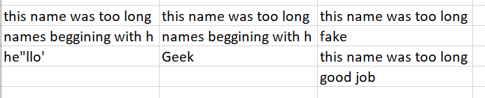

A perfect match to what was expected. Even though he”llo’ must be stored with a backslash it is input to the code correctly as the code just had to print it out and then it is displayed correctly again in the spreadsheet. Showing the inputs work perefctly with any combination of double and single quotes in the inputs.

Test 17

The outupts that are wanted have been slightly edited so that the middle one will not match up with the actual output:

Now in the spreadsheet it is higlighted red:

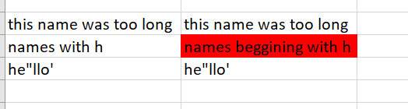

Test 18,19

In the spreadsheet here are the user preferences:

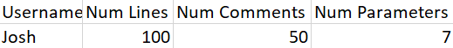

The column is then added to the sql database:
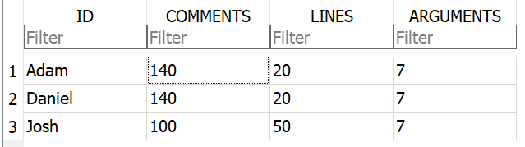

Test 20

TestScript.py is input with Josh username and the number of lines goes red as it it more than 50 lines

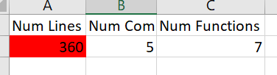

Test 21,22

This is graph generated due to static analysis of TestScript.py:
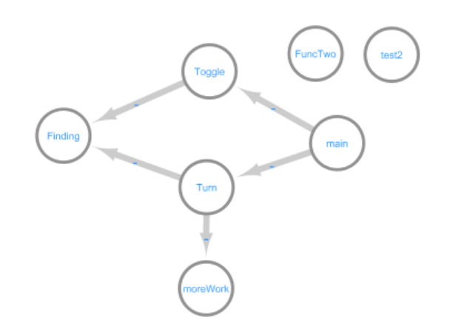
Which looks exactly like it should. You can see FuncTwo and test2 are not called by any functions. MoreWork is a function within the Turn function and you can see it has been statically analysed correctly and placed as its own function that is called from Turn.

Test 23

Looking at table it is clear all previous excel files recorded with timestamps:

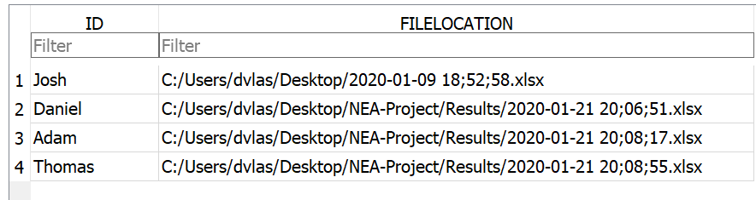

And here is the graph table:

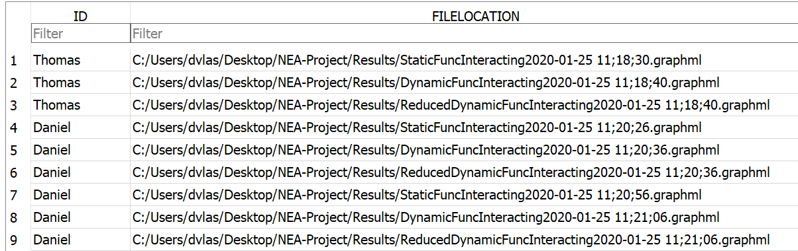

Test 24

This is what inputtest.py originally looks like:

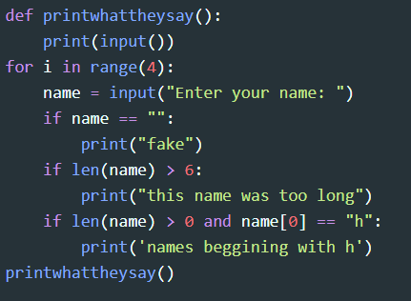

Here is the edited version:

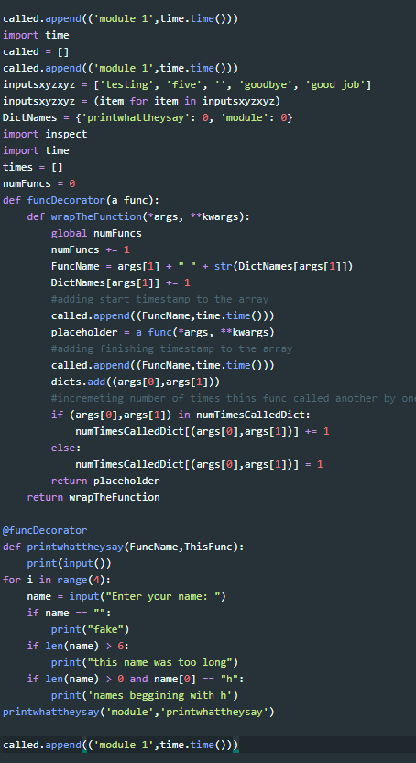

Showing everything in the code has been correctly edited

Test 25
The code below was input to the software. It is clear looking at the code that main should have runtime 5 seconds s1 should have runtime 4 and s2 should have runtime 3.

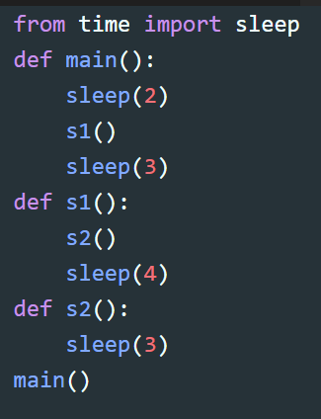

Looking at the graph output it is clear times are correctly calculated:

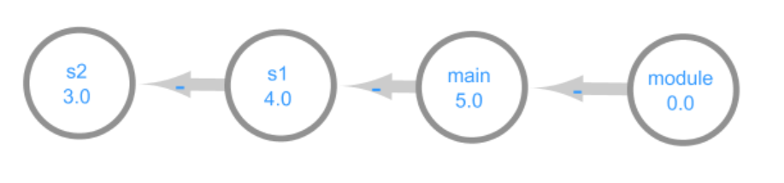
Test 26

Here is the code called testEdges.py:
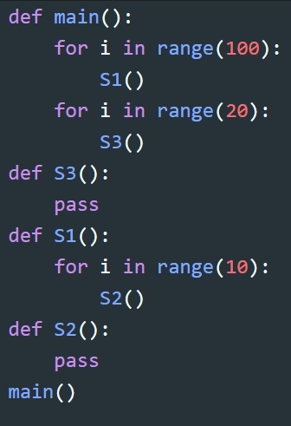

Looking at the code it is clear:
Module calls main once
Main calls S1 100 times
Main calls S3 20 times
S1 calls S2 1000 times (calls 10 times 100 times)

This information is correctly displayed on the edges of the graph.
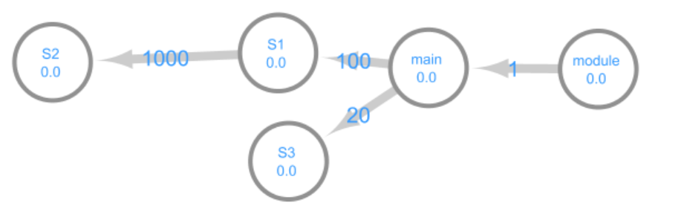

Test 27

Here is dynamic call graph produced with script testscript.py:

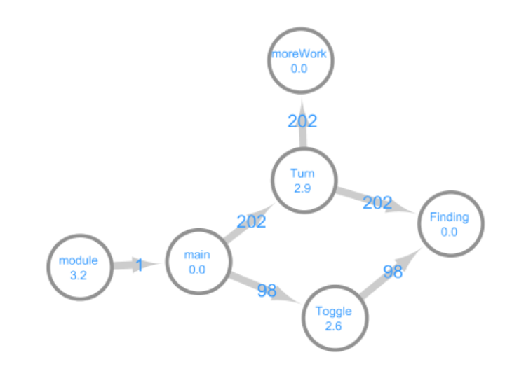
Showing that function call numbers calculated and placed as edge weights. Shows time for functions calculated and placed as text. MoreWork the function within Turn is also displayed as expected showing the code can handle functions within functions. As you can see functions which aren’t called at all are not displayed on the dynamically created graph such as the function test2.

Test 28

Here is a graph that was created by analysing code called reducingtest.py and is the same graph created as used in the demo for the reducing code.

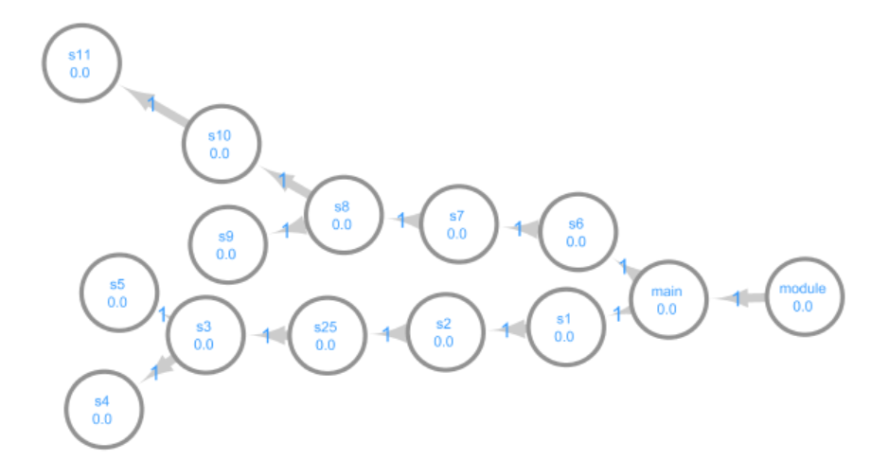
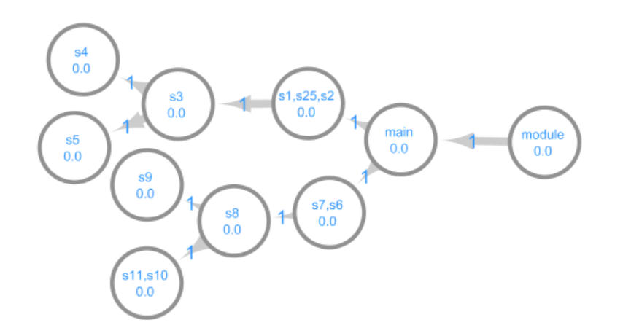

Reduced it looks like this which is the correct reduction of the graph

Test 29a:

Here is the code of Cyclic.py and its call graph:

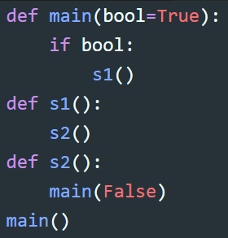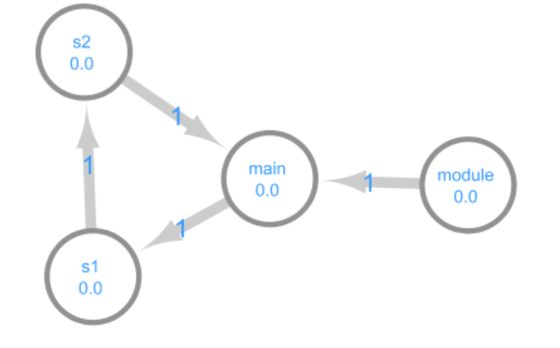

This is cyclic code and a cyclic graph and in the spreadsheet the software says it is:

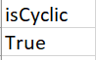

Here is code for a non-cyclic bit of code:
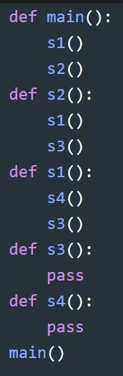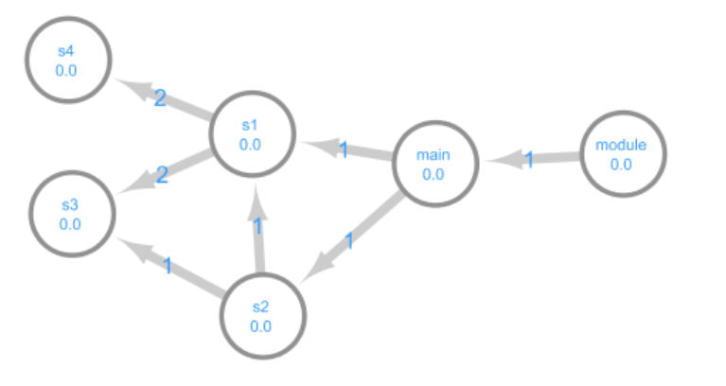

Looking at the spreadsheet the code says it is not cyclic:
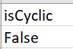

Test 29b:

Using the notCyclic.py code from above the spreadsheet displays a cyclometric complexity of 5:
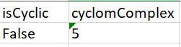

Here are the 5 options:

Module → Main → S1 → S4
Module → Main → S1 → S3
Module → Main → S2 → S1 → S4
Module → Main → S2 → S1 → S3
Module → Main → S2 → S3

Showing 5 is the correct answer.

Videos:

The completed code was turned into an exe using cx_freeze and that is what is used in these videos and how a user would use the software.

Here is a video demonstrating the input functionality of the code using inputtest.py

http://bit.ly/InputsDemo

Here is a video using reducingTest.py to demonstrate the graph reduction functionality

http://bit.ly/ReducingGraphDemo

Here is a video demonstrating the analysis of TestScript.py

http://bit.ly/TestScriptVideo

I made an installer for the exe using NSIS. Here is a demo of the installing and setup of the code and then subsequent running of testScript.py therefore showing how a user would use the code.

http://bit.ly/InstallerAndTestScript

Evaluation

Comparison of project performance against the objectives
I believe all objectives have been met well in the code.

Effectiveness of the solution

I believe the solution is very effective as the user can just input the code and a spreadsheet and can then receive lots of metrics and a very useful call graph from which it is obvious what parts of the code is the bottleneck. One issue I came across was that for very deep recursive programs the software would struggle to calculate the times as the O(n²) algorithm would take too long. The metrics work very well and the software is very useful at displaying all the data in an easy to read table in the spreadsheet.

Another key element of the profiler software was to take in inputs, run the code and record the outputs and this is done perfectly which alongside the timestamps on the file saves is very useful for frequent checking that code meets the objectives during development. Converting it into an exe meant that it can be used as any other application and that the database is stored in the program files and hidden from the user.

Analysis of user feedback
The user said the metrics could be overviewed in the spreadsheet very nicely. Looking at the graph they thought it met the requirements very well. After testing it with their target code they saw that the graph was very helpful in deciding what parts of their code would benefit the most from further improvements. They particularly liked that the straight-line parts were condensed as then it was easier to understand what parts of the code needed improvements. They also thought the timestamps in the file names were very useful so that you could keep track of the metrics analysed.

Possible improvements
The first improvement I would look at would be to make the code that unravels the timestamp array more efficient. This could be done by processing this during the running of the code and therefore would not have such a large time complexity. However, this also comes with disadvantages as then this would change the timings during runtime and be less faithful to the timings of the code.

As a further update the tool could also look at analysing the graph more in depth and trying to locate parts of the code that use lots of time and suggesting these for improvement. The code could also allow comparisons of previous spreadsheets saved, clearly highlighting what metrics have improved and gotten worse for better comparison for the user.

6 Appendix

Testscript.py:

from time import sleep
import random
data = '''turn on 489,959 through 759,964
turn off 820,516 through 871,914
turn off 427,423 through 929,502
turn on 774,14 through 977,877
turn on 410,146 through 864,337
turn on 931,331 through 939,812
turn off 756,53 through 923,339
turn off 313,787 through 545,979
turn off 12,823 through 102,934
toggle 756,965 through 812,992
turn off 743,684 through 789,958
toggle 120,314 through 745,489
toggle 692,845 through 866,994
turn off 587,176 through 850,273
turn off 674,321 through 793,388
toggle 749,672 through 973,965
turn on 943,30 through 990,907
turn on 296,50 through 729,664
turn on 212,957 through 490,987
toggle 171,31 through 688,88
turn off 991,989 through 994,998
turn off 913,943 through 958,953
turn off 278,258 through 367,386
toggle 275,796 through 493,971
turn off 70,873 through 798,923
toggle 258,985 through 663,998
turn on 601,259 through 831,486
turn off 914,94 through 941,102
turn off 558,161 through 994,647
turn on 119,662 through 760,838
toggle 378,775 through 526,852
turn off 384,670 through 674,972
turn off 249,41 through 270,936
turn on 614,742 through 769,780
turn on 427,70 through 575,441
turn on 410,478 through 985,753
turn off 619,46 through 931,342
turn on 284,55 through 768,922
turn off 40,592 through 728,685
turn on 825,291 through 956,950
turn on 147,843 through 592,909
turn off 218,675 through 972,911
toggle 249,291 through 350,960
turn off 556,80 through 967,675
toggle 609,148 through 968,279
toggle 217,605 through 961,862
toggle 407,177 through 548,910
toggle 400,936 through 599,938
turn off 721,101 through 925,455
turn on 268,631 through 735,814
toggle 549,969 through 612,991
toggle 553,268 through 689,432
turn off 817,668 through 889,897
toggle 801,544 through 858,556
toggle 615,729 through 832,951
turn off 427,477 through 958,948
turn on 164,49 through 852,946
turn on 542,449 through 774,776
turn off 923,196 through 980,446
toggle 90,310 through 718,846
turn off 657,215 through 744,252
turn off 800,239 through 811,712
turn on 502,90 through 619,760
toggle 649,512 through 862,844
turn off 334,903 through 823,935
turn off 630,233 through 839,445
turn on 713,67 through 839,865
turn on 932,50 through 982,411
turn off 480,729 through 984,910
turn on 100,219 through 796,395
turn on 758,108 through 850,950
turn off 427,276 through 439,938
turn on 178,284 through 670,536
toggle 540,27 through 625,102
turn off 906,722 through 936,948
toggle 345,418 through 859,627
toggle 175,775 through 580,781
toggle 863,28 through 929,735
turn off 824,858 through 905,973
toggle 752,312 through 863,425
turn on 985,716 through 988,852
turn off 68,504 through 763,745
toggle 76,209 through 810,720
turn off 657,607 through 676,664
toggle 596,869 through 896,921
turn off 915,411 through 968,945
turn off 368,39 through 902,986
turn on 11,549 through 393,597
turn off 842,893 through 976,911
toggle 274,106 through 581,329
toggle 406,403 through 780,950
toggle 408,988 through 500,994
toggle 217,73 through 826,951
turn on 917,872 through 961,911
toggle 394,34 through 510,572
toggle 424,603 through 583,626
toggle 106,159 through 755,738
turn off 244,610 through 472,709
turn on 350,265 through 884,690
turn on 688,184 through 928,280
toggle 279,443 through 720,797
turn off 615,493 through 888,610
toggle 118,413 through 736,632
turn on 798,782 through 829,813
turn off 250,934 through 442,972
turn on 68,503 through 400,949
toggle 297,482 through 313,871
toggle 710,3 through 839,859
turn on 125,300 through 546,888
toggle 482,39 through 584,159
turn off 536,89 through 765,962
turn on 530,518 through 843,676
turn on 994,467 through 994,676
turn on 623,628 through 744,927
toggle 704,912 through 837,983
turn on 154,364 through 517,412
toggle 344,409 through 780,524
turn off 578,740 through 725,879
turn on 251,933 through 632,957
turn on 827,705 through 971,789
toggle 191,282 through 470,929
toggle 324,525 through 446,867
toggle 534,343 through 874,971
toggle 550,650 through 633,980
toggle 837,404 through 881,915
toggle 338,881 through 845,905
turn on 469,462 through 750,696
turn on 741,703 through 892,870
turn off 570,215 through 733,562
turn on 445,576 through 870,775
turn on 466,747 through 554,878
turn off 820,453 through 868,712
turn off 892,706 through 938,792
turn off 300,238 through 894,746
turn off 306,44 through 457,444
turn off 912,569 through 967,963
toggle 109,756 through 297,867
turn on 37,546 through 41,951
turn on 321,637 through 790,910
toggle 66,50 through 579,301
toggle 933,221 through 933,791
turn on 486,676 through 878,797
turn on 417,231 through 556,317
toggle 904,468 through 981,873
turn on 417,675 through 749,712
turn on 692,371 through 821,842
toggle 324,73 through 830,543
turn on 912,490 through 977,757
turn off 634,872 through 902,949
toggle 266,779 through 870,798
turn on 772,982 through 990,996
turn off 607,46 through 798,559
turn on 295,602 through 963,987
turn on 657,86 through 944,742
turn off 334,639 through 456,821
turn off 997,667 through 997,670
turn off 725,832 through 951,945
turn off 30,120 through 952,984
turn on 860,965 through 917,976
toggle 471,997 through 840,998
turn off 319,307 through 928,504
toggle 823,631 through 940,908
toggle 969,984 through 981,993
turn off 691,319 through 865,954
toggle 911,926 through 938,929
turn on 953,937 through 968,991
toggle 914,643 through 975,840
turn on 266,982 through 436,996
turn off 101,896 through 321,932
turn off 193,852 through 751,885
turn off 576,532 through 863,684
turn on 761,456 through 940,783
turn on 20,290 through 398,933
turn off 435,335 through 644,652
turn on 830,569 through 905,770
turn off 630,517 through 905,654
turn on 664,53 through 886,976
toggle 275,416 through 408,719
turn on 370,621 through 515,793
turn on 483,373 through 654,749
turn on 656,786 through 847,928
turn off 532,752 through 945,974
toggle 301,150 through 880,792
turn off 951,488 through 958,952
turn on 207,729 through 882,828
toggle 694,532 through 973,961
toggle 676,639 through 891,802
turn off 653,6 through 905,519
toggle 391,109 through 418,312
turn on 877,423 through 957,932
turn on 340,145 through 563,522
turn off 978,467 through 988,895
turn off 396,418 through 420,885
turn off 31,308 through 816,316
turn on 107,675 through 758,824
turn on 61,82 through 789,876
turn on 750,743 through 754,760
toggle 88,733 through 736,968
turn off 754,349 through 849,897
toggle 157,50 through 975,781
turn off 230,231 through 865,842
turn off 516,317 through 630,329
turn off 697,820 through 829,903
turn on 218,250 through 271,732
toggle 56,167 through 404,431
toggle 626,891 through 680,927
toggle 370,207 through 791,514
toggle 860,74 through 949,888
turn on 416,527 through 616,541
turn off 745,449 through 786,908
turn on 485,554 through 689,689
turn on 586,62 through 693,141
toggle 506,759 through 768,829
turn on 473,109 through 929,166
turn on 760,617 through 773,789
toggle 595,683 through 618,789
turn off 210,775 through 825,972
toggle 12,426 through 179,982
turn on 774,539 through 778,786
turn on 102,498 through 121,807
turn off 706,897 through 834,965
turn off 678,529 through 824,627
turn on 7,765 through 615,870
turn off 730,872 through 974,943
turn off 595,626 through 836,711
turn off 215,424 through 841,959
toggle 341,780 through 861,813
toggle 507,503 through 568,822
turn on 252,603 through 349,655
toggle 93,521 through 154,834
turn on 565,682 through 951,954
turn on 544,318 through 703,418
toggle 756,953 through 891,964
turn on 531,123 through 856,991
turn on 148,315 through 776,559
turn off 925,835 through 963,971
turn on 895,944 through 967,964
turn off 102,527 through 650,747
toggle 626,105 through 738,720
turn off 160,75 through 384,922
toggle 813,724 through 903,941
turn on 207,107 through 982,849
toggle 750,505 through 961,697
toggle 105,410 through 885,819
turn on 226,104 through 298,283
turn off 224,604 through 508,762
turn on 477,368 through 523,506
turn off 477,901 through 627,936
turn off 887,131 through 889,670
turn on 896,994 through 938,999
toggle 401,580 through 493,728
toggle 987,184 through 991,205
turn on 821,643 through 882,674
toggle 784,940 through 968,959
turn off 251,293 through 274,632
turn off 339,840 through 341,844
turn off 675,351 through 675,836
toggle 918,857 through 944,886
toggle 70,253 through 918,736
turn off 612,604 through 772,680
turn off 277,40 through 828,348
toggle 692,139 through 698,880
toggle 124,446 through 883,453
toggle 969,932 through 990,945
toggle 855,692 through 993,693
toggle 722,472 through 887,899
toggle 978,149 through 985,442
toggle 837,540 through 916,889
turn off 612,2 through 835,82
toggle 560,767 through 878,856
turn on 461,734 through 524,991
toggle 206,824 through 976,912
turn on 826,610 through 879,892
turn on 577,699 through 956,933
turn off 9,250 through 50,529
turn off 77,657 through 817,677
turn on 68,419 through 86,426
turn on 991,720 through 992,784
turn on 668,20 through 935,470
turn off 133,418 through 613,458
turn off 487,286 through 540,328
toggle 247,874 through 840,955
toggle 301,808 through 754,970
turn off 34,194 through 578,203
turn off 451,49 through 492,921
turn on 907,256 through 912,737
turn off 479,305 through 702,587
turn on 545,583 through 732,749
toggle 11,16 through 725,868
turn on 965,343 through 986,908
turn on 674,953 through 820,965
toggle 398,147 through 504,583
turn off 778,194 through 898,298
turn on 179,140 through 350,852
turn off 241,118 through 530,832
turn off 41,447 through 932,737
turn off 820,663 through 832,982
turn on 550,460 through 964,782
turn on 31,760 through 655,892
toggle 628,958 through 811,992'''

sleep(1)

lights = [[0 for _ in range(1000)] for i in range(1000)]

def Finding(c1,c2):
smallx = min([c[0] for c in [c1,c2]])
bigx = max([c[0] for c in [c1,c2]])
smally = min([c[1] for c in [c1,c2]])
bigy = max([c[1] for c in [c1,c2]])
return smallx,bigx,smally,bigy

def Turn(c1,c2,lights, type):
def moreWork():
pass
moreWork()
global totalTurn
totalTurn += 1
smallx,bigx,smally,bigy = Finding(c1,c2)
for x in range(smallx,bigx+1):
for y in range(smally,bigy+1):
lights[y][x] = type

def Toggle(c1,c2,lights):
global totalToggle
totalToggle += 1
smallx,bigx,smally,bigy = Finding(c1,c2)# kjjjjjjjjj
for x in range(smallx,bigx+1):
for y in range(smally,bigy+1):
lights[y][x] = 1-lights[y][x]
#JFFLJJKJJKFKJFKJFFKs
def main():
for row in data.splitlines():
items = row.split()
dictionary = {"on":1,"off":0}
if items[1] in dictionary:
c1 = [int(i) for i in items[2].split(',')]
c2 = [int(i) for i in items[4].split(',')]
Turn(c1,c2,lights,dictionary[items[1]])
else:
c1 = [int(i) for i in items[1].split(',')] #UGFKHDFJDFJKFDJKDFJKKJDFKJFKJFKJF
c2 = [int(i) for i in items[3].split(',')]
Toggle(c1,c2,lights)
print(sum([sum(row) for row in lights]))

def FuncTwo():
pass

#this is a commnet
def test2(a):
pass
totalToggle = 0
totalTurn = 0
main()
print(totalTurn*10)
print(totalToggle)
#this is a comments
print("#this is not an acutal’ comment")

testinput.py:

def printwhattheysay():
print(input())
for i in range(4):
name = input("Enter your name: ")
if name == "":
print("fake")
if len(name) > 6:
print("this name was too long")
if len(name) > 0 and name[0] == "h":
print('names beggining with h')
printwhattheysay()

cyclicTest.py:

def main(bool=True):
if bool:
s1()
def s1():
s2()
def s2():
main(False)
main()

reducingTest.py:

def main():
s1()
s6()

def s1():
s2()

def s2():
s25()

def s25():
s3()

def s3():
s4()
s5()

def s4():
pass

def s5():
pass

def s6():
s7()

def s7():
s8()

def s8():
s9()
s10()

def s9():
pass

def s10():
s11()

def s11():
pass

main()

notCyclic.py:

def main():
s1()
s2()
def s2():
s1()
s3()
def s1():
s4()
s3()
def s3():
pass
def s4():
pass
main()

